oSHELL SCRIPTING BY ARKIT:
- How command works?
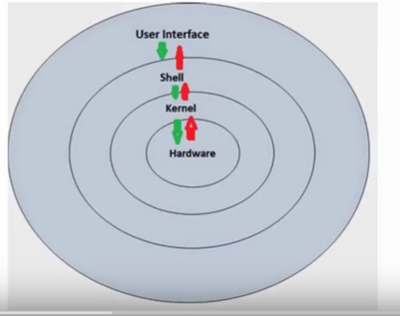
- cp -R= To copy the directory
- diff -c <1st file> <2nd file>=To check the exact difference between two files
- grep <search word> <file name>=To search for the word in the file
- grep file[^1234] <file name>=This will print those are not having file name 1,2,3,4 numeric value
- grep <file name>$ <file name>=This shows sentences present in that particular file
- grep test.*txt <file name>=This will show all available files ending with txt extension
- grep h[aiofg]t <file name>=This shows words having h in first and t at ending with middle letter with aiofg
- cd /var/log->more messages=It will show all contents in messages files, we can also use=cat messages | more
- sort -nk1 <file name>=This will sort the first colomn
- sort -rk1 <file name>=This sorts the first colomn with reverse way
- sort - u <file name>=Simple sorting command
- sort is also using to remove the duplicates(Ex: sort {file-name} | uniq -u)
- tail -f <file1> <file2>=To open the multiple files
- tr a-z A-Z < <File name>=This will change the character from the lower case to upper case
- tr a-z A-Z <File name>=This will change all the character to upper case in that particular file
- cat <File name> | tr -d A =This will delete all the "A" character in this file
- tr -d [:digit:]=This will delete all the digits from the file
- echo “my name is Pabitra” | tr [:space:] ‘\t’
- wc <file name>=To check the number of words and character in this file
- wc -l=To check the number of lines
- wc -c=To check the number of character
- free=To see the memory and swap memory utilization
- free -s 2=It will give every 2 secs utilization
- free -c 3=It will show the utilization for 3 times only
- df=Disk partition utilization
- df -i=It gives the inode information
- df -t xfs=It will show only the xfs file system usage details
- du -sh=To view the size of particular directory
- du -cbha --time /etc=To see all the available files and directory along with size and time
- fdisk -v=To check the disk utility version
- parted /dev/sda unit GB print free=To view the details of available and free space size
- /usr/local/share/man=path of Man page
- whoami=To check the user login name
- W=To check the system uptime along with load average(CPU utilization average in every 5, 10,and 15 mins)
- id -z=This will give selinux contest of the particular user
- who=This shows all login user details
- who -r=This will show which runlevel is currently running
- who -q=count of the user logged in(how many user logged in)
- who -b=system boot time
- last=To know the details of reboot and when it logged in
- finger=To know user details like login name, Name, shell details and time zone and how many mails came to user (we need to install finger to use this command=yum install finger)
- uname -a=To know the version details of os(kernel version, hardware details and time)
- uname -r=To know kernel version
- uname -n=host name
- hostname -f=To know full hostname
- hostname -i=To know the ip address of that particular hostname
- hostnamectl set-hostname <Assign hostname> --static=To assign permanent hostname
- hostnamectl status=This will show all the details of hostname locate <Filename>=This will show you the all the available files with complete path
- If you create a find and then use the command locate, then it won’t show this file and you need to use the command updatedb command, then it will show that path of new created file
- Find / –name <filename>=This will show you the file name path in /
- Find . –name <filename>=This will show the file name in the current directory
- Find /root -type f -name “<filename>*”=This will show the path of file name only
- Find /root -type d -name <dir name>=This will show path of the directory only
- Find / –iname <filename>=This will ignore the case sensitivity and if you type mismatch of case in file also, this can locate that path of file name.
- Find / -not -name Pabitra(we can use –not=! Also, this means same for both)=This will list all the path of files including hidden files except Pabitra file/directory
- Find /root -name “.*”=This will list all the hidden files
- Find /root -perm 777=This will list all the files or directories which is having 777 permission in /root
- Find /root -maxdepth 1 -perm /u=r=To list all the read only permission files/directories
- /a=x=For execute permission
- Find /root -mtime 10=To check the details of the modified files within 10 days
- Find /root -atime 10=To check the details of accessed files within 10 days
- Find /root -mtime +10 -mtime -20=To check the details of modified files from last 10-20 days
- Find /root -cmin -60=This will list the files which is modified with last 60 minutes
- Find / -size 1M=This will list all the files size of 1MB
- Find /root type f empty=To list all the empty files
- Find /root -group admin=To list all the files listed in group name admin
- Find /root -type f -name “*.txt” -exec rm -f {} \;=This will delete all the .txt files available in /root
- Find / -type f -size +1000k -exec ls -lh {} \; | awk “{print $9 “: “ $5 }”=To list all 100kb files and print all the files having this size
- Top=To see all the process IDs on the system and if you press C, this will show all the processes along with the path and K and process ID to kill a process
- Or kill -s PID=To kill a process
- And press z to show the top command processes in color display
- Top=>R=>then enter the renice value, so if you enter the nice value high, then priority will be less and vice versa.
- In every 3 sec top command out put get refreshed as this is default time, but if you want to refresh this faster then this then we need to press d and then enter the value as 1 to make refresh in every 1 sec.
- To split the processes into multiple screen for top command, we need to enter “shift a”
- Top -n 10=It will refresh 10 times and exit from the processes details
- Top -p <process ID> -n 5=This will show particular process with 5 times iterations.
- We can use l, e and m to view different types of output in top command
- Top -d1 -b > <Filename>=This will save the top outputs in file in every 1 sec refreshment as we used d1 and that will continuously store the outputs to that particular file
- Sed is used to modify the files. Sed ‘s/<name to which you want to replace>/<replacement name>’ <Filename(In which file you want to replace)>
- Sed ‘s/<name to which you want to replace>/<replacement name>/2’ <Filename(In which file you want to replace)>=This will replace the second occurrence(For example refer screen shot available in desktop)
- Sed ‘s/<name to which you want to replace>/<replacement name>/g’ <Filename(In which file you want to replace)> = This will replace the all occurrences
- Sed ‘s/<name to which you want to replace>/<replacement name>/2g’ <Filename(In which file you want to replace)>=This will replace the all occurrences which will start from second occurrences
- Sed ‘s/^\(arkit\)$/#\1\1’ <File name>=To comment the line which is arkit only without entering inside the file.
- Sed -i ‘s/^\(arkit\)$/#\1\1’ <File name>=To save the comment permanently
- Sed ‘s/http:\/\//www./’ <filename>=To replace / or \ with www
- Sed ‘3 s/arkit/technology/’ <filename>=This replace technology in case of arkit only in 3rd line.
- Sed ‘3 d’ <filename>=To delete the 3rd line from a particular file
- Sed –i ‘3 d’ <filename>=To delete permanently from that file
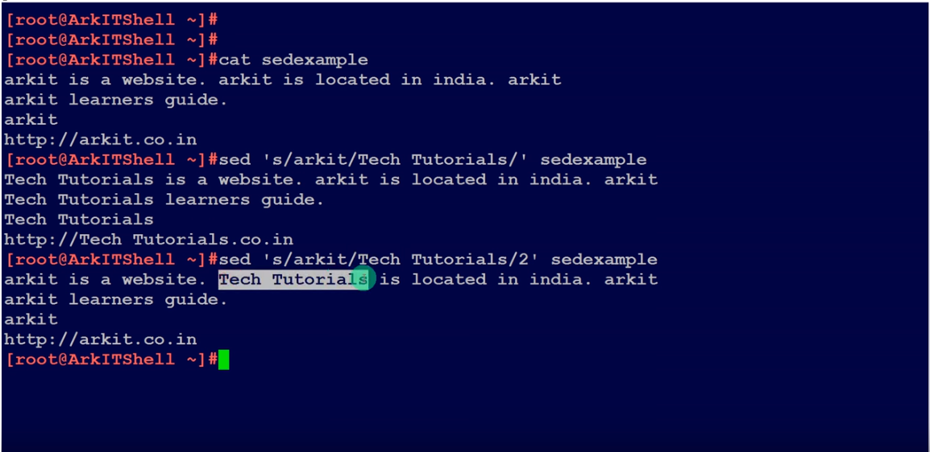
- Cat <filename> | awk ‘{ print $3,$9 }’=This will give output only 3rd and 9th colomn(For example refer screen shot available in desktop). Also we can get output of other colomn just adding at print $ followed by commas
- Awk ‘BEGIN {sum=0} {sum=sum+$7 END {print sum}’ <filename>=To add the colomn
- Awk -f <file which is written the coding> <file name(in which we need that code run)>=To run that scripting to anyfile
- Awk ‘{ if($3 == “arkit”) print $0:}’ <filename>=To get the output of particular files which 3rd colomn is arkit from any particular file
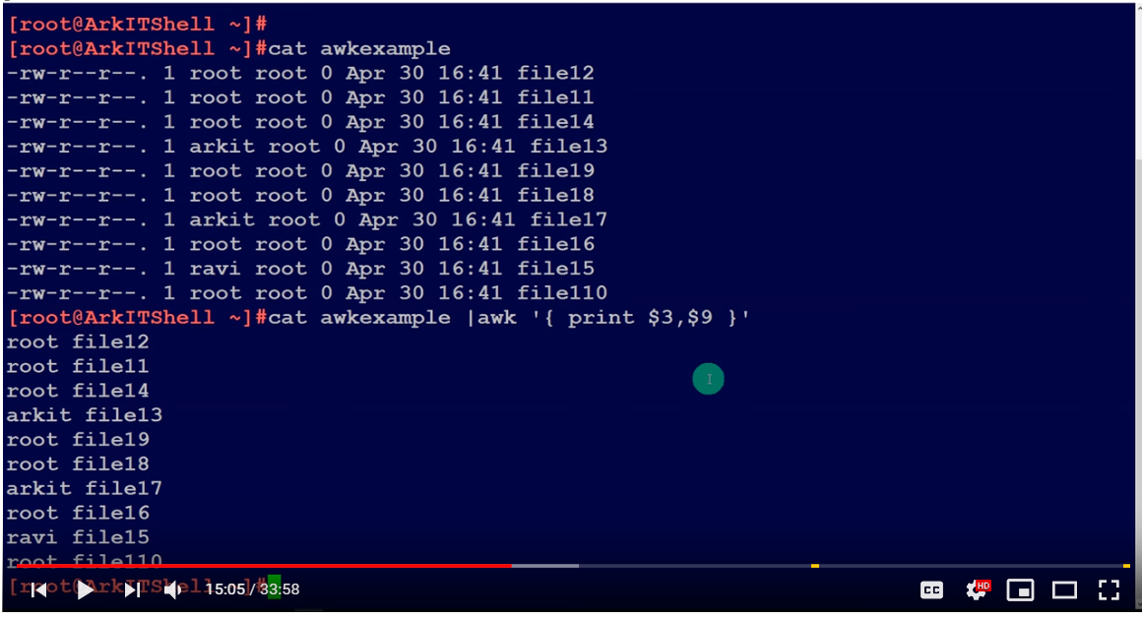
- Vmstat -a=To view the virtual memory status like processors, memory, swap and i/o, cpu usage.
- Vmstat -f=To view the folks details(Folks is a library that aggregates from multiple sources)
- Vmstat -m=for memory details
- Vmstat -t=To see all the time details of processes
- Vmstat -t 3 10=This will display the output of vms in every 3 secs for 10 times
- Netstat -tunlp=To check if all port is listening or not
- Mail=To see all the emails details
- Mail -s “Hello” <email address>=This will send email
- echo “testing email” | Mail -s “Hello” <email address>=This Hello will be the subject of email and testing email will be body of the email.
- mail -s “hello admin” <email address> < <filename>=here this file will send to that particular email with hello admin as subject.
- mail -s “hello admin” <email address> < -a <filename> =This will send the file as an attachment
- For CC we need to mention as –c <CC email> and for BCC –b
- cut command =Remove sections from each line of files
- Example : echo “Pabitra” | cut -b 1 => output : P
- To cut a range of bytes then echo “Pabitra” | cut -b 1-4 =>output : Pabi(This will cut 1st letter to 4th letter)
- cat <filename> | cut -c 1,3,4,6 = This will cut the 1st, 3rd, 4th and 6th character and show the output.
- cat <filename> | cut -c3- = This will cut the character from 3rd to last.
- cut -d’:’ -f1 /etc/passwd = This will show only the first field
- cat /etc/passwd | cut -d’:’ --complement -s -f1=This will show everything apart from field 1
- cat /etc/passwd | cut -d’:’ -s -f1,4 --output-delimiter=’$’ = This will give output by replacing the : with $
- cat /etc/passwd | cut -d’:’ -s -f1,4 --output-delimiter=$’\n’ = This will give output as separated to next line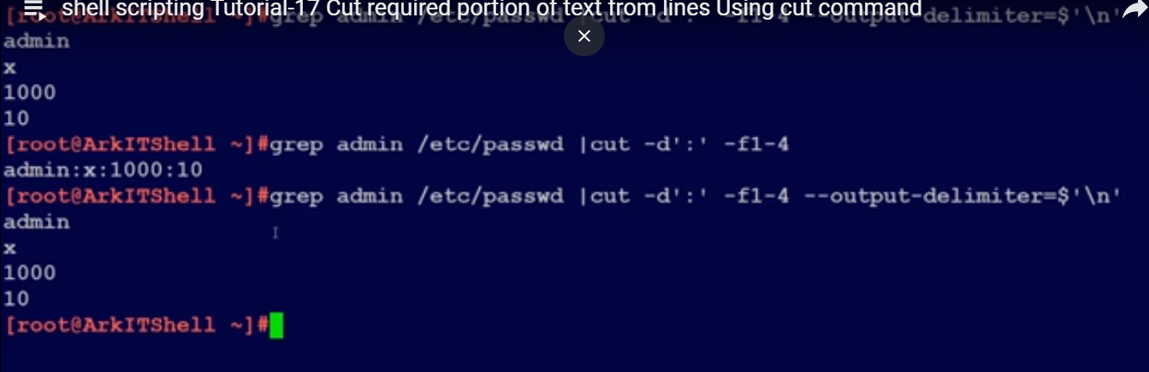

- paste <file1> <file2>=To merge both the file as file1 and file2
- paste -s <file1> <file2> = To merge both files as side by side
- paste -d: -s <file1> = To use delimiter in a file
- paste -d’\n’ <file1> <file2>=To make separate line in every joining of two files
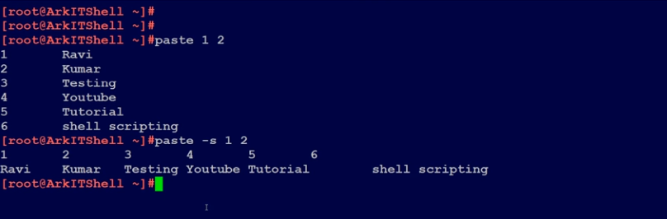

- paste -d ‘ ‘ file[AB] | cut -d ‘ ‘ -f 1,2,4,5 = To merge both files A and B, then get the output of only 1, 2, 4, and 5 fields
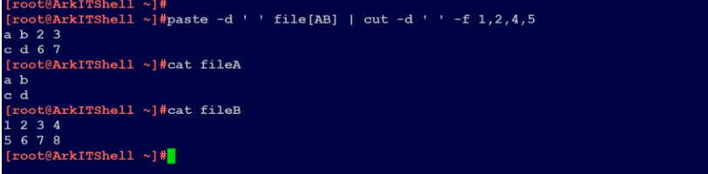

- SSH Meaning: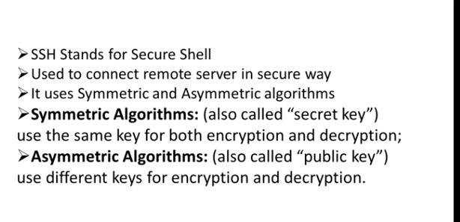
- ssh root@<ip> =To connect the server from the client device, then it will ask you to authenticate this
- cd .ssh | ls = here you will find known_host, where this ip will be added
- ssh-keygen -t rsa = To show the key finger print
- cat .ssh/id_rsa.pub=You can see the keys and copy this key from here then go to remote host and paste this key there at vi .ssh/authorized_keys, if it shows no file then systemctl restart sshd.
- Use ssh_keygen -t rsa at remote side, then cd .ssh | ls, if authorized_keys file is not there then create and save the key
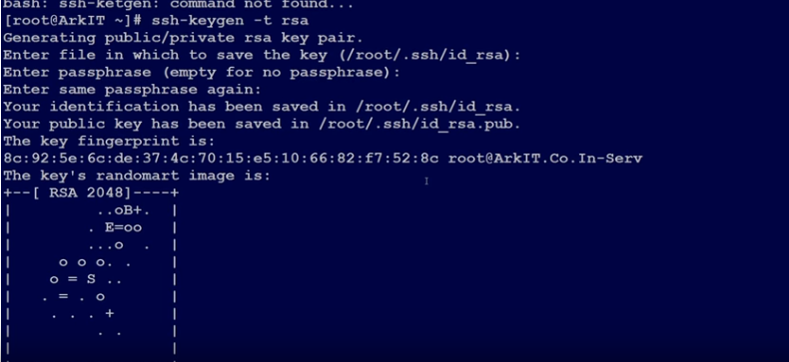
- scp <file1> <destination IP>:<destination file location to where you want to copy>
- scp -r = To copy a directory, In simple scp command the date of the file or directory may change, so preserve exact same at destination scp -vp then file and if directory copying then scp -rvp
- scp -P 22 <filename> <destination IP>:<destination location where you want to copy>= To copy the file to different location with different port number.
- scp -C <filename> <destination IP>:<destination location where you want to copy>==To copy the file to destination with compressing the data, in this the data transfer will be faster then the normal one.
- scp -l 500 <filename> <destination IP>:<destination location where you want to copy>=This will copy the data to destination within 500 Kbps speed only, this requires while we do not want to impact our network
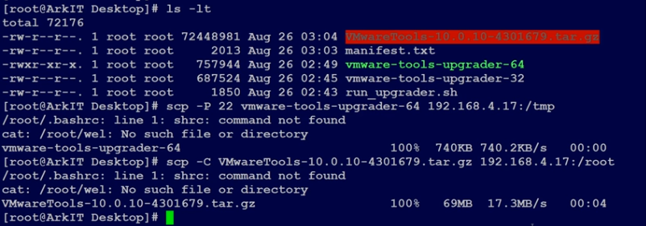
- chmod 777 <filename>=To give the full access as r=4, w=2 and x=1
- chmod u+x <filename> = To give the access to user executable permission and for others o+x and for group g+x
- chmod ugo+rw <filename> = To give the read and write permission to all user, group and others
- chown root:admin <filename> = To change the ownership of group of a particular file name
- chgrp root <filename>=To change the owner ship of group
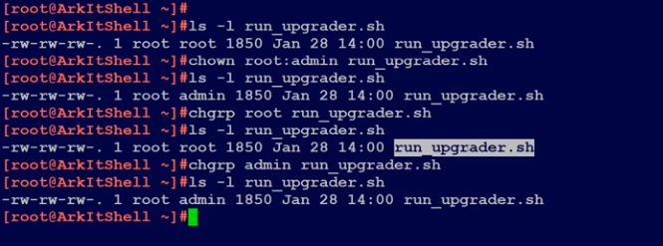
- Archieve file is collection of few files, the size is same as all collected files, but compressed file is not same as archieved files.
- tar -cvf archieve.tar pab*=To create the archieve file combined with all pab* files
- tar -uvf archieve.tar pab*=To update archieve files and if you made any changes in any file, it will update automatically at background and it will show the file name as output
- tar -cvzf compress.tar.gz pab*=To compress these pab* files(For Example follow screen shot)
- tar -tf <archieved file> = To see the details of archieved file
- cat /etc/crontab=To see the details of crontab
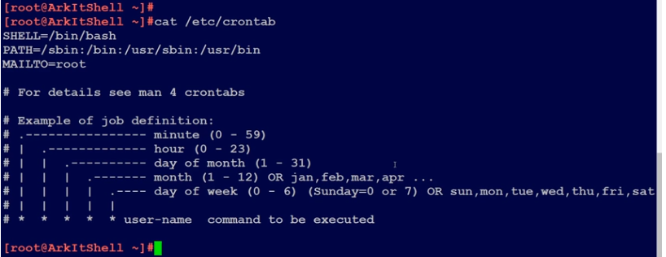
- crontab -e =To create the cron jobs
- crontab -l =To list out the scheduled jobs
- crontab -u <username> -e =To schedule the cron job for any other user
- sh <scripting filename whose extension will be sh>=To execute the scripting file
- Advantage of schell scripting is we can reduce our daily work manual jobs and convert these for automation with scripting commands
- If ls or cat or touch any command is not working, then we need to use the command as /bin/ls or /bin/cat or /bin/touch. so that it will work.
- To make this above commands work as normal, we need to use the PATH+/usr/bin and so on
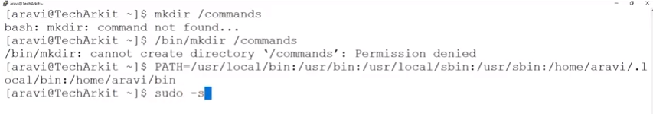
- PATH=$PATH:/command=To extend the PATH environment to /command directory
- cat /etc/shells=To see the different types of shells
- First shell scripting:
vi /myfirstshell.sh
  - #!/bin/bash
  - ##This is my first shell scripting commands
  - echo “Welcome $USER”
  - echo “Your present working directory is `pwd`”
  - echo “The current date is `date`”
  - :Wq
  - # sh myfirstshell.sh
  - Output: Welcome aravi(as per the registered user name)
    - Your present working directory is /scripts
    - The current date is 19 June 2019 (IST)
  - we can use also ./<.sh file name> to execute the script
  - We can also use source <.sh filename>=To execute scripting file
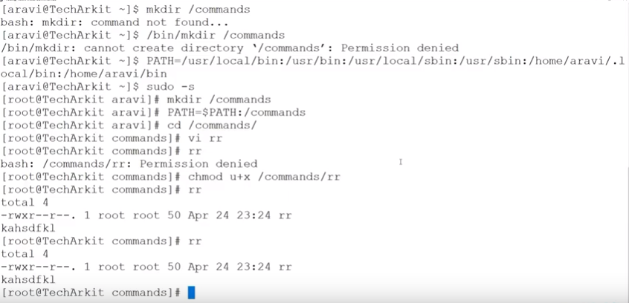
- To create the template of a general script
- #vi <filename>
- echo -e “Please provide the file name you want to create: \c
- read -r file
- touch /scripts/$file.sh
- echo ‘#!/bin/bash’ > /scripts/$file.sh
- echo ‘#Purpose:’ >> /scripts/$file.sh
- echo ‘#Version:’ >> /scripts/$file.sh
- echo ‘created date:’ `date` >> /scripts/$file.sh
- echo ‘Modifiled date:’ >> /scripts/$file.sh
- :wq
- <filename> then it will ask for file name and it will create a .sh file then add the details in that file to run the script
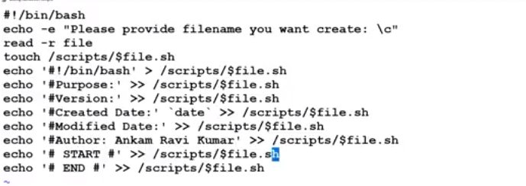
- Difference between double and single quotes :

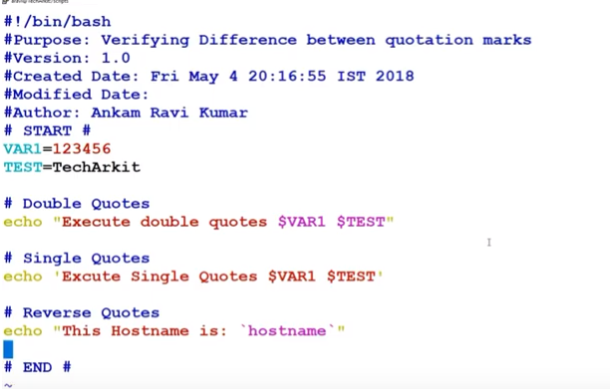
Output:
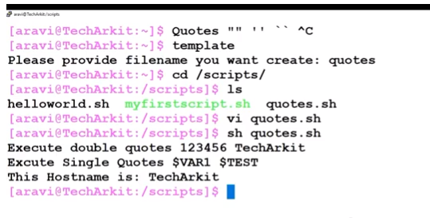
- Variable is usually used as $(dollar) symbol
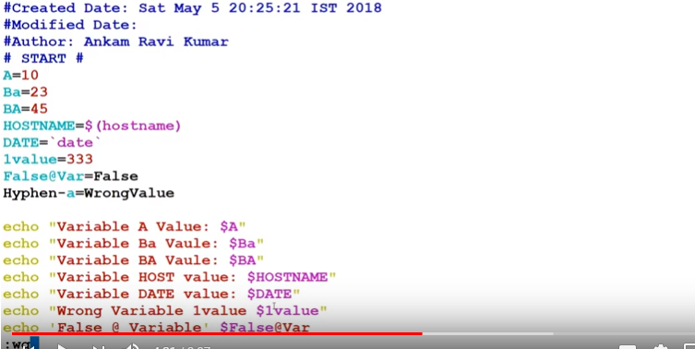Output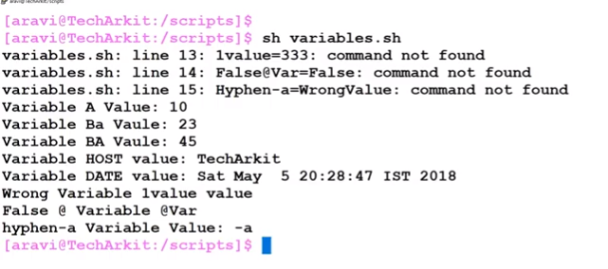

155) $*, $#, $1, $2, $0, “$@”, $?, $$, $!=These are the special variables in shell scripting
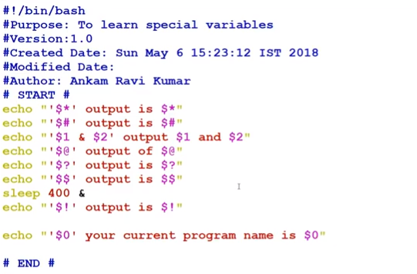
Output:
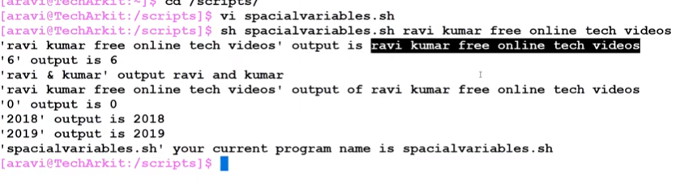
- $* = This will store at the given position as a single string
- $# = This will count how many we have given for positional parameter
- $1 and $2 =This is the positional parameter
- $@= This is same as $* but it will take all the positional parameter in to consideration
- $?=This will display the exit status
- $$=This will display the PID of current shell
- $!=The PID of last background job
- $0=This will capture the provided shell scripting name
- To see the scripts for counting positional parameter
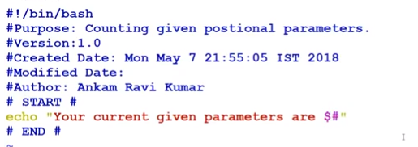
Output:
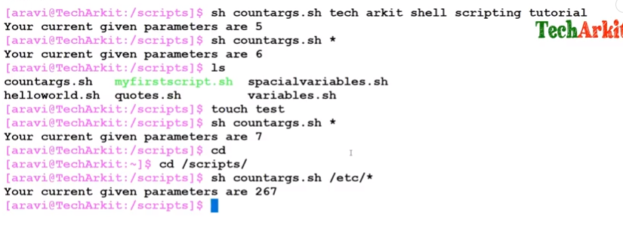
- if [ $# -lt 1 ]; then=>This will count the positional parameter if this is less than 1, then it will print the 1st statement or else second
- echo “ Program usage is ‘./scriptname’ options”
- else
- echo “Program executed successfully”
- fi
- Then we will run this script as sh <.sh extension file>
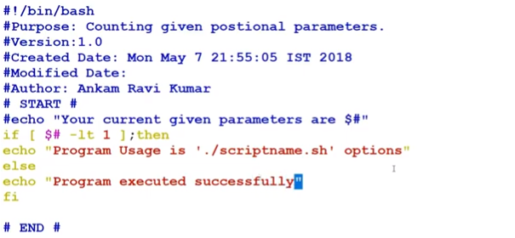
Output:
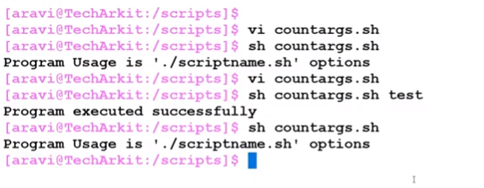
- Logical operator: To write multiple condition, validate multiple conditions and execute the statement.
- AND (-a) (&&) OR (-o) (||) NOT (-n) (!)
- True+True=True True+True=True False=True
- True+False=False True+False=True True=False(Opposite condition)
- False+True=False False+True=True
- False+False=False False+False=False
- Logical operators or Boolean operators: Student mark validation
- vi studentmark.sh
- echo -e “ Enter the mark of student in Math : \c”
- read -r M
- echo -e “ Enter the mark of student in Physics : \c”
- read -r P
- echo -e “ Enter the mark of student in Chemistry : \c”
- read -r C
- if test $M -ge 35 -a $P -ge 35 -a $C -ge 35(if we use the operator symbol like for AND &&, OR || and NOT !, then we should write like
[[ $M -ge 35 && $P -ge 35 && $C -ge 35 ]])
- then
- echo “Congratulations, You are passed in all subjects”
- else
- echo “Sorry, You are failed”
- fi
- :wq
- sh studentmark.sh
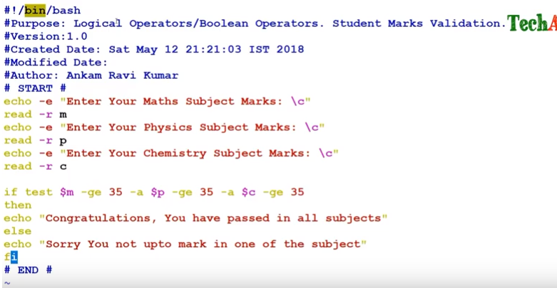
- OR operator: Here in if statement, we should use [ ] square bracket,
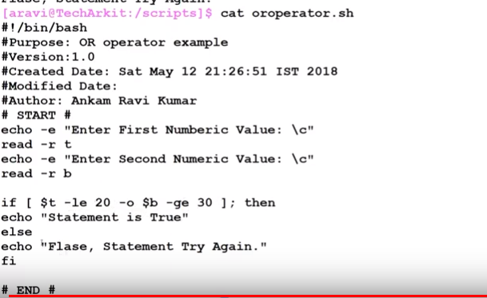
- 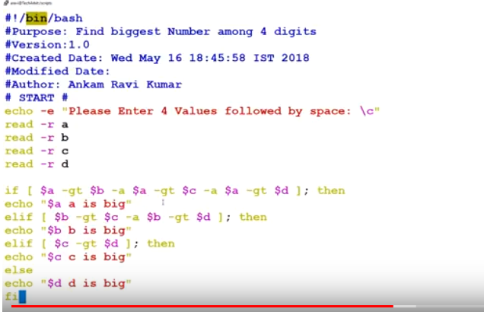
- Relational operator:
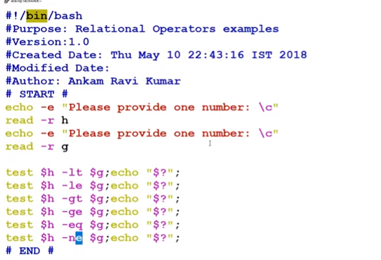
Output:
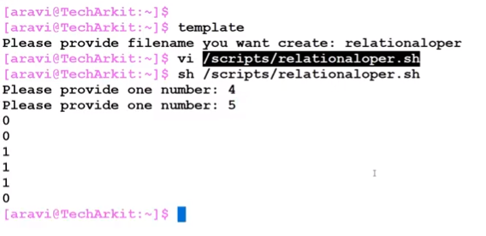
- Nested If statement :
- vi nestedif.sh
- echo -e “Please enter the mark of Math: \c”
- read -r M
- echo -e “Please enter the mark of Physics: \c”
- read -r P
- echo -e “Please enter the mark of Chemistry: \c”
- read -r C
- if [ $M -ge 35 -a $P -ge 35 -a $C -ge 35 ]; then
- total = `expr $M + $P +$C`
- avg = `expr $total / 3`
if [ $avg -ge 75 ]; then
echo “Congratulation, You have got Distinstion”
elif [ $avg -ge 60 -a $avg -lt 75 ]; then
echo “Congratulation, You have got First Division”
elif [ $avg -ge 50 -a $avg -lt 60 ]; then
echo “Congratulation, You have got Second Division”
elif [ $avg -ge 35 -a $avg -lt 5o ]; then
echo “Congratulation, You have got Third Division”
fi
else
echo “Sorry, You are faied”
fi
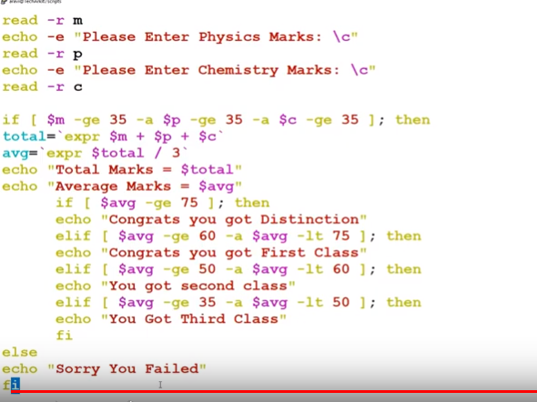
Output:
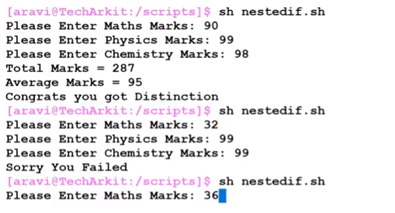

- While loop: In this loop, commands are executed till the condition is valid. Once condition becomes false, loop terminates.
- Infinite loop is also called endless loop. It is made with while true (it means condition will always be true) or while : (it means an empty expression), where colon (:) is equivalent to no operation.
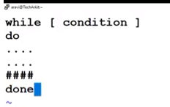
# vi whileloop
#echo -e “Please provide a value: \c”
#read -r c
#i=1
#while [ $i -le 10 ]
#do
#b=`expr $c \* $i`
#echo “$c * $i = $b”
#i = `expr $i + 1`
#done
Screen shot example:
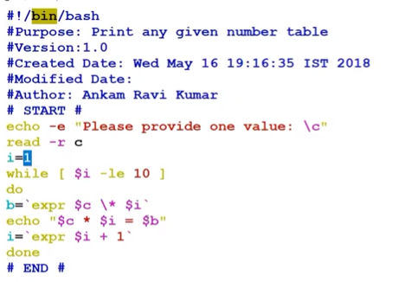
Output:
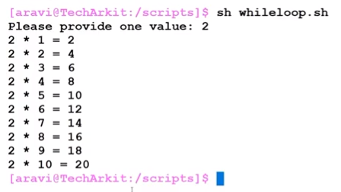
- For loop:
Format:
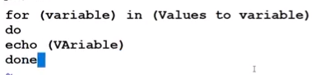
Example of For loop:
#vi hostfile
local host
127.0.0.0
127.0.0.1
google.com
arkit.com
:wq
#vi forloop.sh
for i in `cat hostfile`
do
ping -c 1 $i
valid=`echo $?`
if [ $valid -gt 1 ]; then
echo “$i Host is not reachable”
else
echo “$i Host is up and running fine”
fi
done
:wq
#sh forloop.sh
Screen shot:
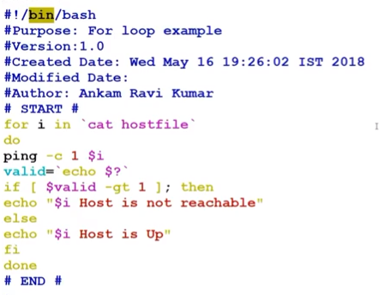
Output:
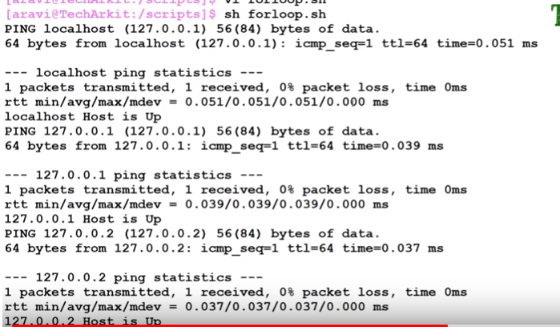
- Case statement which is an unconditional statement.
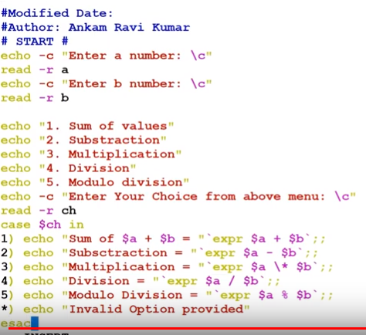
Output:
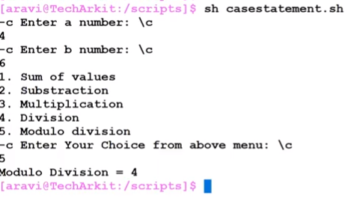

- Another example of case statement:
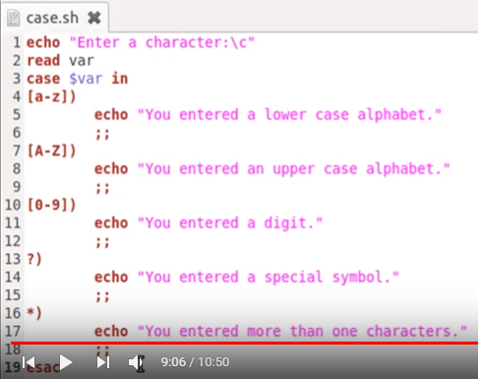
Output:
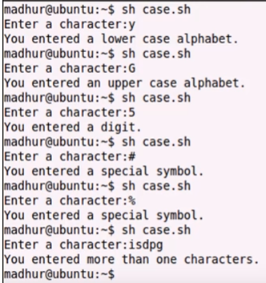

- Continue statement:
#vi continuestatement.sh
opt=y
while [ $opt=y -o $opt=Y ]
do
echo -e “Please enter the number: \c”
read -r num
if [ $num -le 50 ]; then
sq=`expr $num \* $num`
echo “Square of given number $num: $sq”
else
echo “ Number is out of range”
fi
echo -e “Do you want to continue [Y/N]: \c”
read -r wish
if [ $wish=y -o $wish=Y ]; then
continue
else
echo “Thank you for exiting”
exit
fi
done
:wq
#sh continuestatement.sh
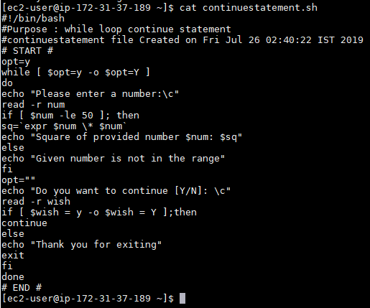
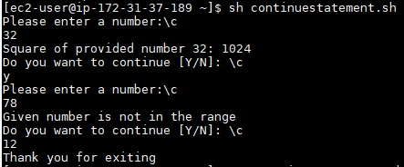
- Set: This assigns its arguments to the positional parameter
Example:
#vi set.sh
set `date`
echo “Today is $1”
echo “Month is $2”
echo “Date is $3”
echo “Time H:M:S is $4”
echo “Timezone is $5”
echo “Year is $6”
:wq
#sh set.sh
Screen shot:
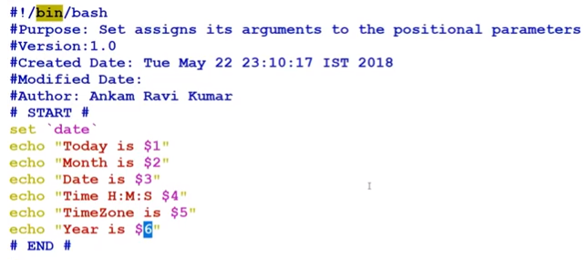
Output:
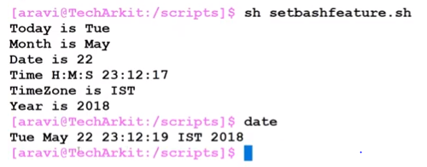
- Shift positional parameter: On Unix-like operating systems, shift is a builtin command of the Bash shell. When executed, it shifts the positional parameters (such as arguments passed to a bash script) to the left, putting each parameter in a lower position.

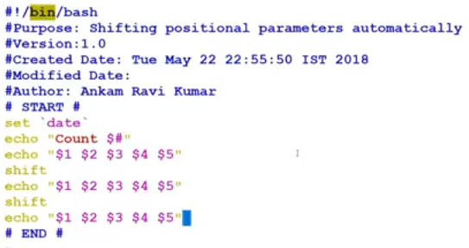
Output:
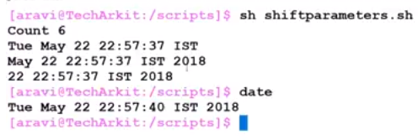
- A function is a group of commands that are assigned a name that acts like a handle to that group of commands. To execute this group of commands defined in the function, you simply call the function by the name you provided.
It helps us to reuse the code.
• Improve the readability of the program.
• Efficient use of variables inside the program.
• Allows us to test the program part by part.
• Displays program as a bunch of sub-steps.
Syntax to use:
Syntax1:
function function_name
{
###set of commands
}
Syntax2:
function_name()
{
####set of commands
}

In the first syntax, you must use the keyword function, followed by your function name and open and close parentheses and curly braces to separate the contents of your functions to your main routine.
In the second syntax, consists of a function name, open and close parentheses and curly braces.
- Example to take backup of a particular file:
#vi backup.sh
function takebackup () {
if [ -f $1 ]; then
BACKUP=”/home/aravi/$(basename ${1}).$(date + %F).$$”
echo “Backing up $1 to $BACKUP”
cp $1 $BACKUP
fi
}
takebackup /etc/hosts
if [$? -eq 0]; then
echo “Backup done successfully”
fi
Screen shot:
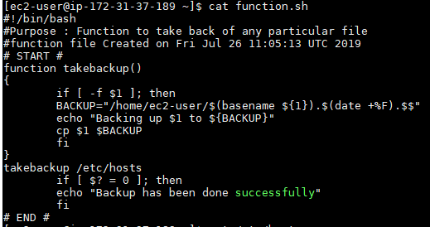
Output:
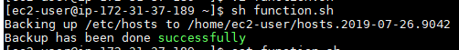
How to call a function on the same scenario: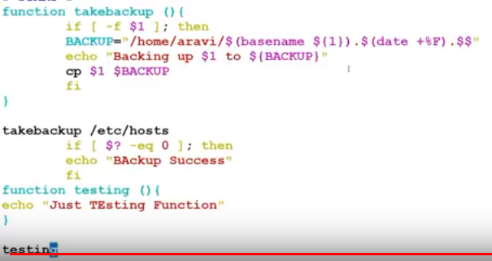
Output:
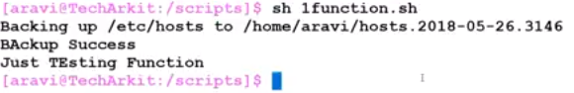
- Shell Scripting until loop. It is similar to while loop. The only difference is that until statement executes its code block while its conditional expression is false, and while statement executes its code block while its conditional expression is true.
- Until loop example for host pinging:
#vi untilloop.sh
echo “Please enter the IP address to ping: \c”
read -r IP
until ping -c 3 $IP
do
echo “Host $IP is still down”
sleep 1
done
echo “Host $IP is up now”
Screen shot:
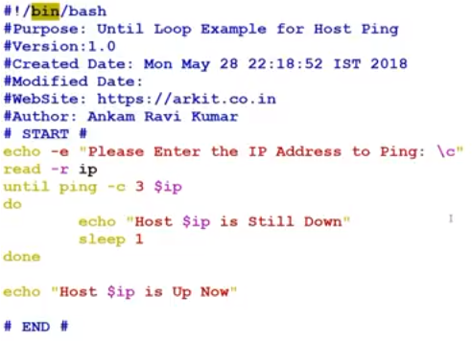Output:
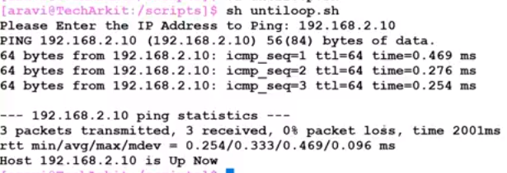
Different IP which is down:
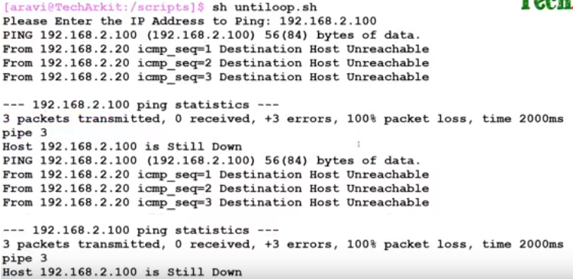
This will continute till the IP is up.
- Array: Array is a variable which contains multiple values may be of same type or different type since by default in shell script everything is treated as a string.
- In Shell script Array is a variable which contains multiple values may be of same type or different type since by default in shell script everything is treated as a string. An array is zero-based ie indexing start with 0.
- We can declare an array in a shell script in different ways.
- Indirect Declaration
In Indirect declaration, We assigned a value in a particular index of Array Variable. No need to first declare.
Syntax : ARRAYNAME[INDEXNR]=value
- Explicit Declaration:
In Explicit Declaration, First We declare array then assigned the values.
Syntax : declare -a ARRAYNAME
- Compound Assignment
In Compount Assignment, We declare array with a bunch of values. We can add other values
later too.
Syntax : ARRAYNAME=(value1 value2 .... valueN)
OR
[indexnumber=]string
ARRAYNAME=([1]=10 [2]=20 [3]=30)
- To Print All elements
[@] & [*] means All elements of Array.
echo ${ARRAYNAME[*]}
Example:
#vi arrary.sh
fruits=( “apple” “Orange” “Banana” “sapota”)
for fruit in ${fruits[ @] }
do
echo “Fruit name is $fruits”
done
echo “Types of fruits in the basket is ” ${#fruits[ @ ]}
echo “All fruits are ${fruits [ @ ]}”
Screen shot:
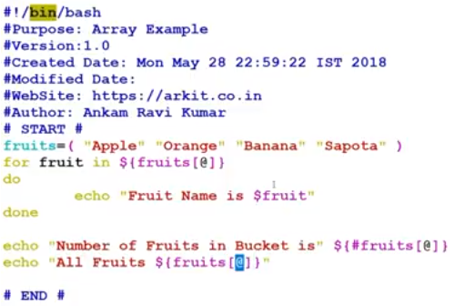

Output:
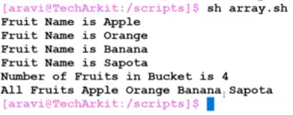
- We can also replace the array like fruits(3)=”Green apple”, so the 3rd position of the array will change to Green apple.
- Important: In arithmatic for interger value we use command as expr but for floating values it won’t work, so for this we will use bc.
Ex : echo `expr $a * $b` = For interger value
echo $a * $b | bc
- To make the output to bold letter:
#vi shellscripts.sh
echo “”\033{1mHey, how are you?\033{0m
Output: Hey, how are you?(This will get it in bold letter)
- tput:
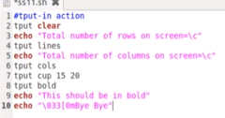
Output will not show the command prompt in the very first line and here you can get the number of rows and colomns.
Output:
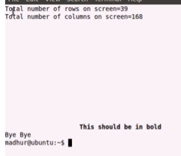
- If you want to check whether the entered name in shell script is file/directory or having read, write and execute permission, then we will use the syntax as
[ -f $enteredname ] = This will check only for files
[ -d $enteredname ] = This will check only for directories
[ -r $enteredname ] = This will check for read permission
[ -w $enteredname ] = This will check for write permssion
[ -x $enteredname ] = This will check for execute permission
[ -s $enteredname ] = This will consider only for files having few sizes
- We can use double semicolon(;;) to come out or exit from the syntax or commands.
- grep -i = This will show the output with ignoring the case sensitivity
- grep -n <search name> = This will show the output with line number
- grep -c = To see the number of lines matching with the search name
- grep -v <Search name>= This will reflect only the outputs of lines in text file which are not having search name
- Password file related script:
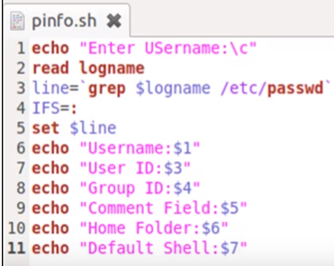
Output:
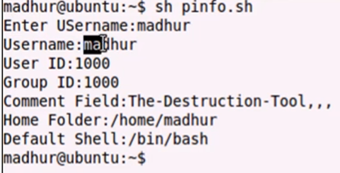

- Read the file with line number:
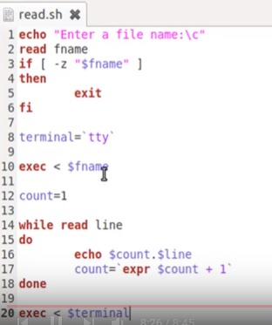
Output:
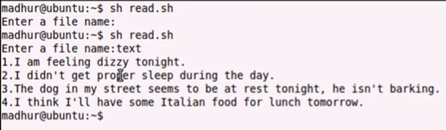
Here in this above example, we have already created a file text which has all the sentences without line number.
- Count number of words and sentences in a text file:
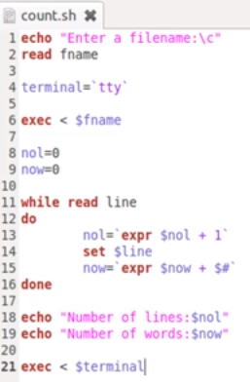
Output:
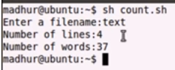
- Nested loop:
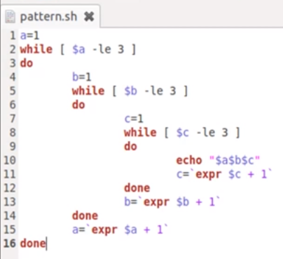
Output:
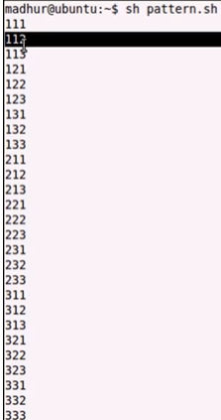
- To check the time when the user logged in script:
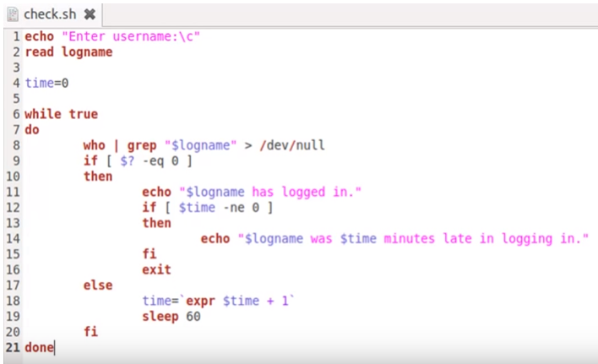
Output:
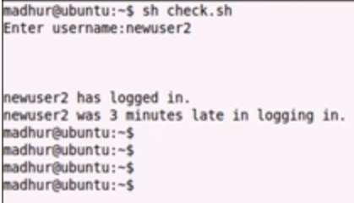
- To get the minutes syntax will be (min=`expr $time / 60`) but we need to assign the time=0. Similarly for sec(sec=`expr $time % 60`)
- To send the message from one terminal or user to another:
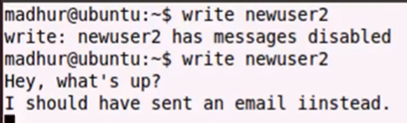
Another terminal:
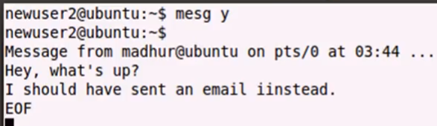
You can press any key after EOF to get the terminal command prompt back.
- Create your own function:
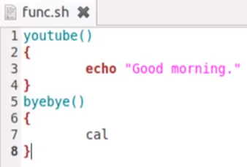
But we will not be able to run the command like scripting command, this will be little different and follow the below screen shot to execute and use as your own function.
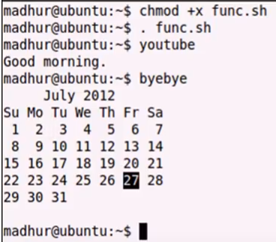
Further, if you want to remove any function like youtube or byebye then use the command as #unset <function name like youtube or byebye>
- getopts: The getopts command is an argument to a while loop - each time through the loop, it processes the switch, and sets the $c variable to the character of the switch. You can read more about loops and case in the main tutorial.
#!/bin/bash
unset DB_DUMP TARBALL ACTION
while getopts 'srd:f:' c
do
case $c in
s) ACTION=SAVE ;;
r) ACTION=RESTORE ;;
d) DB_DUMP=$OPTARG ;;
f) TARBALL=$OPTARG ;;
esac
done
if [ -n "$DB_DUMP" ]; then
case $ACTION in
SAVE) save_database $DB_DUMP ;;
RESTORE) restore_database $DB_DUMP ;;
esac
fi
if [ -n "$TARBALL" ]; then
case $ACTION in
SAVE) save_files $TARBALL ;;
RESTORE) restore_files $TARBALL ;;
esac
fi

Example:
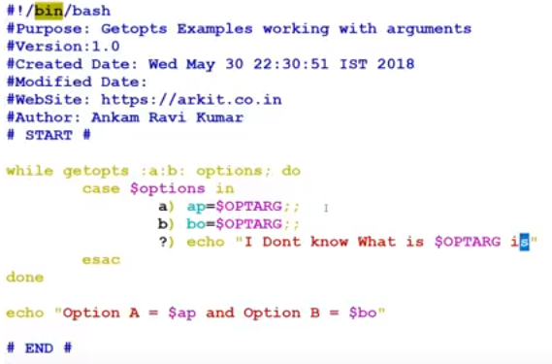
Output:
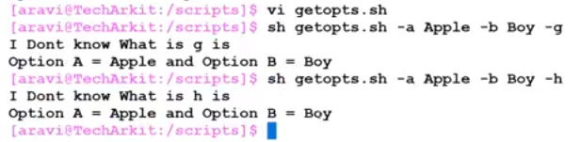
- Real Time CPU utilization:
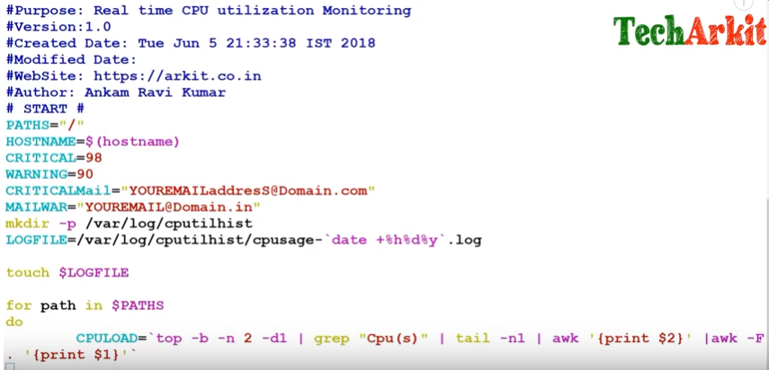
Splitwise of CPULOAD commands output:
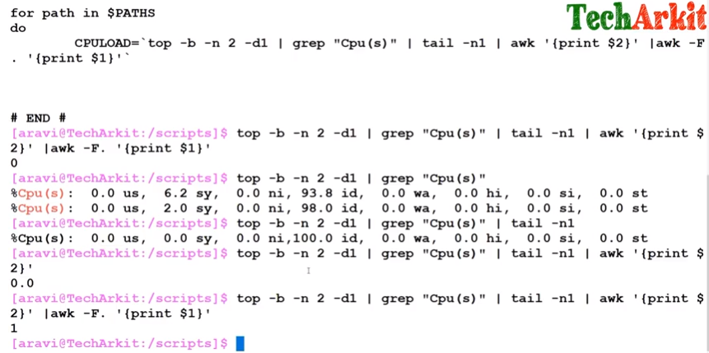
Scripts for CPU utilization:
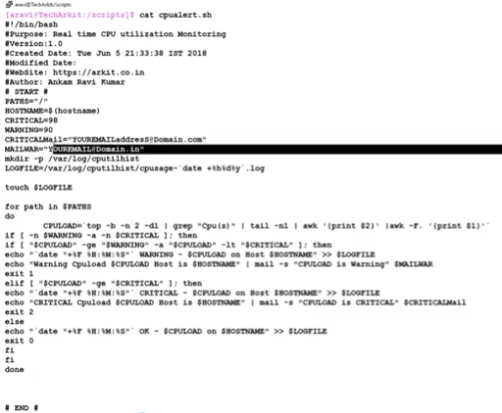
Output:
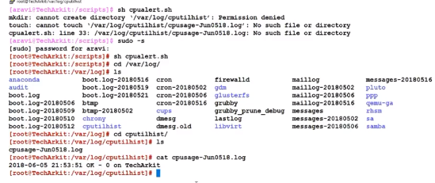
After that, we can schedule the crontab job to run this command in every 5 or 10 minutes. Please follow below to do this cron jobs
#crontab -e
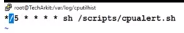
So here in every 5 minutes, it will run this script
- Disk space utilization and send alerts with deleting the temp files:
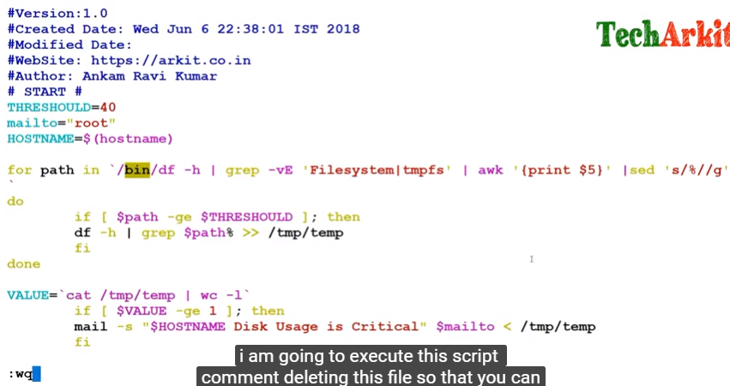
Output:
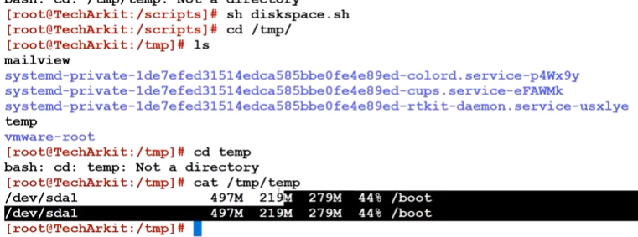
If we do not delete the temp file, then you can see outputs as below
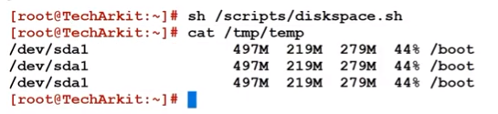
- Debug shell scripting:
To debug any scripts, we need to run the command like
sh -x <file name>
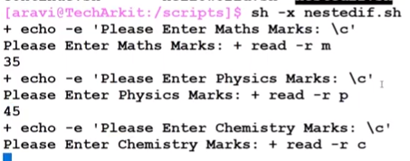
- If you are copying any script from any other format of file, then we need to convert that file to unix file as #dos2unix <Filename>, we have to run this command as root access.
- We can also debug the script through https://www.shellcheck.net/, we just put the script then it will show us the error details in that particular script.
- We can use the scripts in two different ways, just follow the difference in below two screen shots.
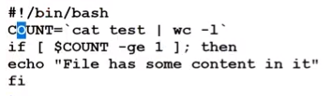
Screenshot-2:
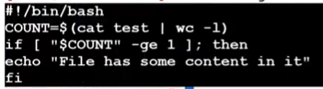
Here, both the scripts will work perfectly and second screen shot is a best practice in scripting.
- Here documents in shell scripting:
In this we can use 3-4 lines without echo command every time.
Example:
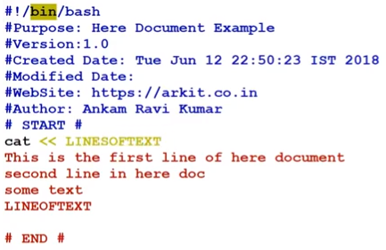

- Another Example:
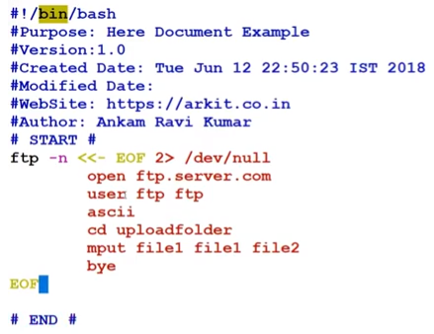
- Internal field separator:
- Without separator example:
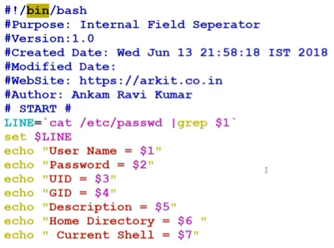

Output:
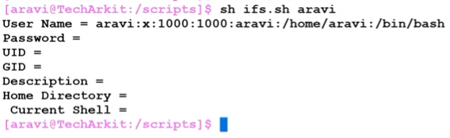
- With separator:
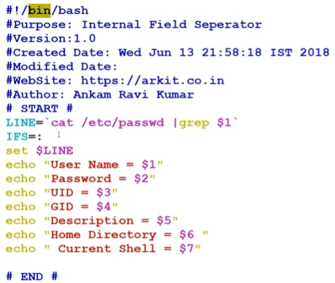

Output:
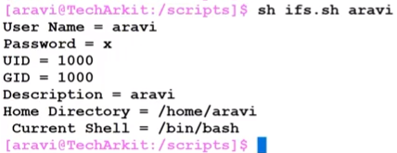
- Eval command: The eval command is a built-in command. It takes a string as its argument and evaluate it, then run the command stored in the argument. It allows using the value of a variable as a variable.
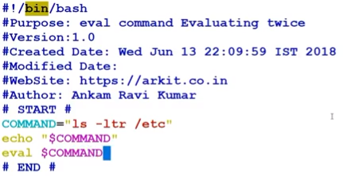
If we won’t use eval command, then we will get the output as it is, but if we use eval command then we will get the output with executing the specified command like above.
Output of the above script:
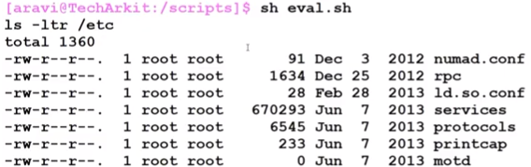
- Execute single scripts into multiple servers:
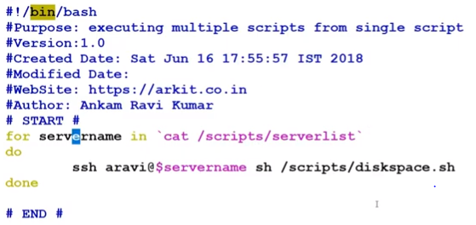
- logger commands:
- The Linux logger command provides an easy way to add log files to /var/log/syslog — from the command line, from scripts, or from other files.
- This easy. Just type logger <message> on the command line and your message will be added to the end of the /var/log/syslog file.
- Log message System rebooted for hard disk upgrade
- $ logger System rebooted for hard disk upgrade
- You can see message in /var/log/message file
- # tail -f /var/log/message
Output:
- Jan 26 20:53:31 dell6400 logger: System rebooted for hard disk upgrade
- To log a message contained in the /var/log/myapp.log file, use:
- $ logger -f /var/log/myapp.log
- Log the message to standard error (screen), as well as the system log:
- $ logger -s "Hard disk full"
- Refer to the man page for more options:
- man logger
- man syslogd
- man syslogd
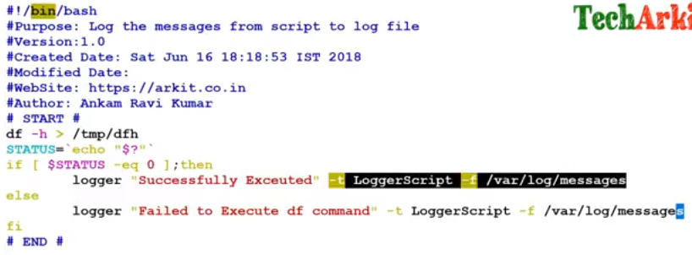
Output:
sh logger.sh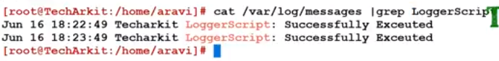
- Questions: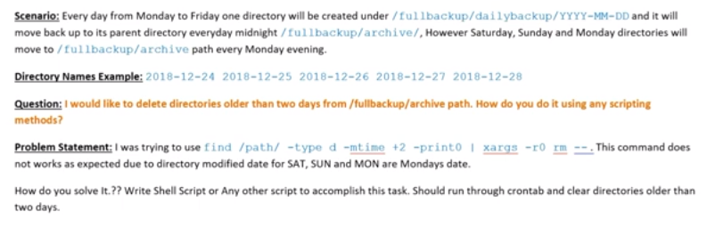
Answer:
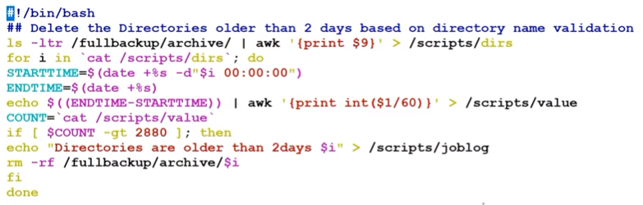

Splitwise answers for the above scripts:
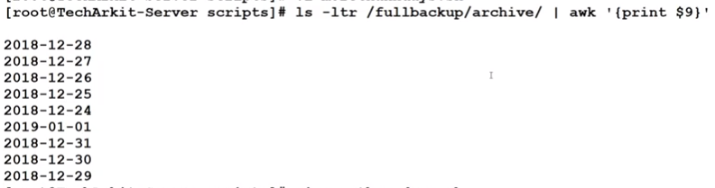
Current epoc time (date +%s)and previous time(Second date script on below screen shot):
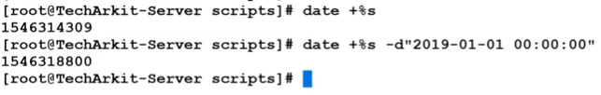
Output:
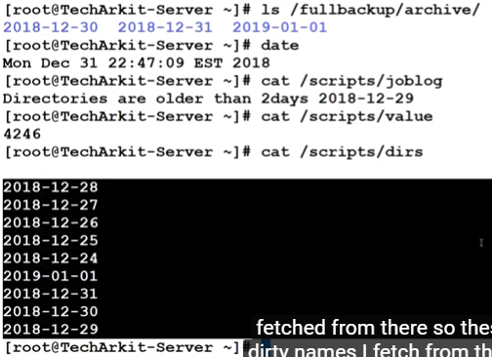

- Create multiple users:
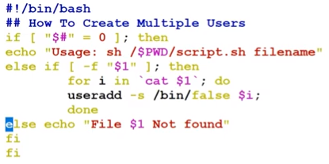
sh <filename>
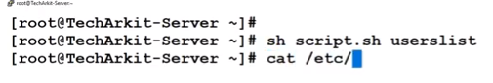
That is #cat /etc/passwd to see the users created
However, we need to make a file with userlist with having users. below screen shot can be used for reference:
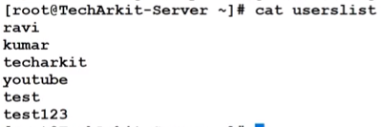

- System load average check script:
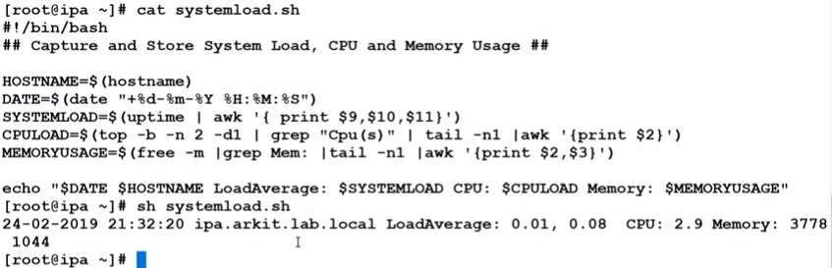
The above script is only for the local system load average but let’s see for remote system load average
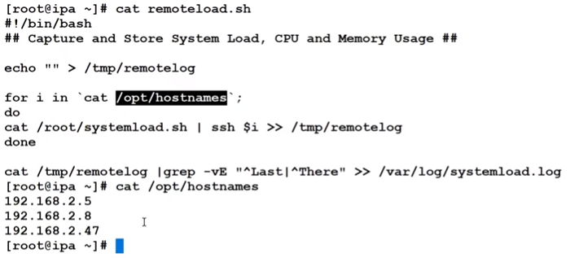

Output:
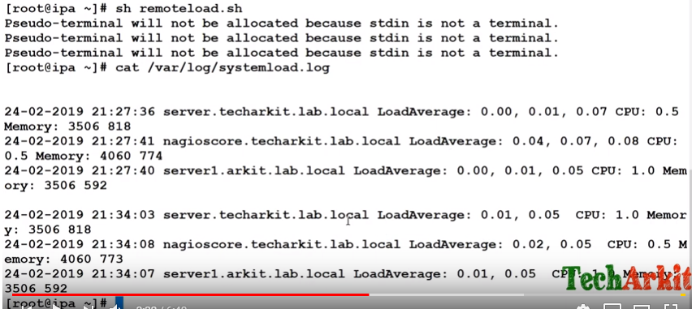
We can run this script in every 5 minutes for which we need to schedule the cron jobs with command
#crontab -e
Before this we have to make the password less command prompt.
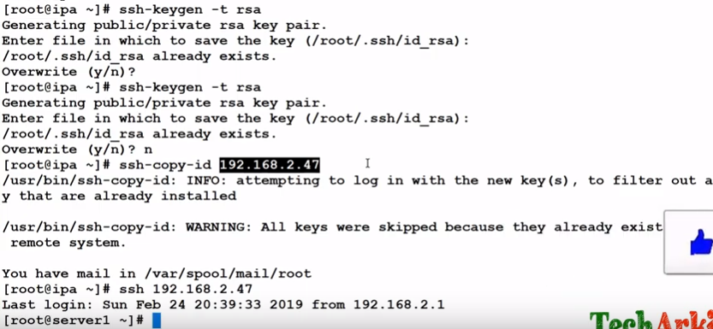

- unary operator expected means that you do a comparison where one site is empty for example.
if [ $name = "foo" ]
and $name is empty. Then the bash shell internally replaces $name by an empty string and it will be interpreted as
if [ = "foo" ]
and this is not a valid expression
The solution is to quote variable names like this:
if [ "$name" = "foo" ]
Then it will work.
- Unary operator is also called as file test operator and this is used for file testing also used to verify the file existance or to check permissions and so on.
-b = To check whether it is block special device or not /dev/sda1
-c = To check whether it is character special file or not /dev/tty
-d = Directory
-e = file exist
-f = Regular file or any special file
-g = To check the group ID(SGUID bit set)
-h = Symbolic link
-G = To check file is owned by the effective group ID
-k = To check whether the file has sticky bit or not
-L = Symbolic link verification
-O = Owned by effective user ID
-p = Used to verify the file type is named pipe or not
-r = file is readable
-s = Verify the size greater than zero because sometimes we use empty file
-S = To check whether the file is socket file or not
-u = To check whether the file is set user ID
-w = To check whether the file has writable permission or not
-x = To check whether the file has executable permission or not
There are used to check the file charactristics.
Example-1:
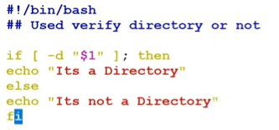
Output:
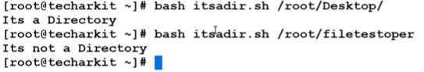

Example-2:
To check whether file exist or not:
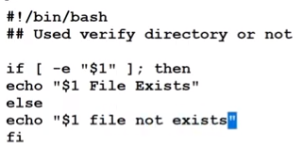
Output:
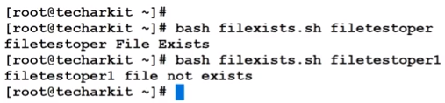
Example-3:
To check whether device is block device or not:
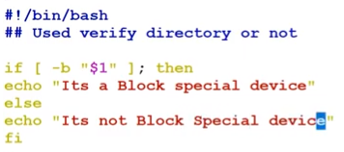

Output:
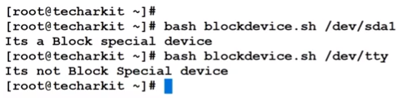
Options in unary operator:
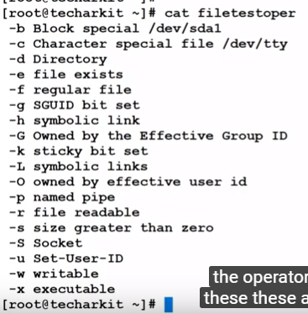
- CPU, Memory and Disk utilization reports from multiple servers.

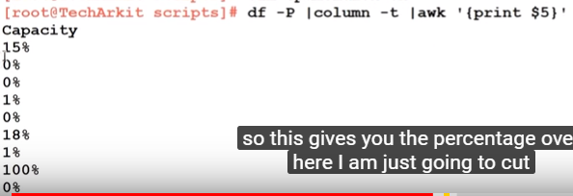
Scripts for CPU, Memory and Disk utilization report in both local and remote servers:
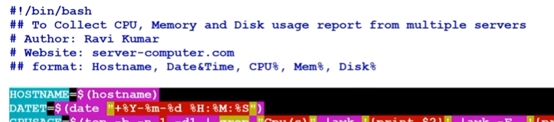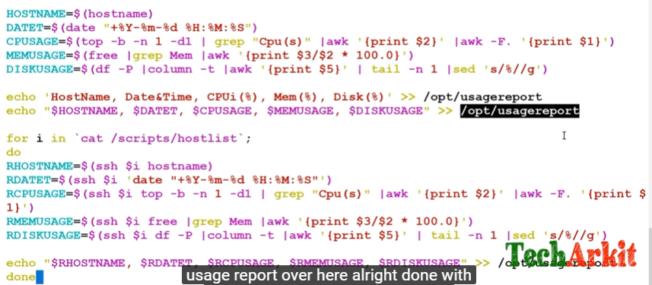
We need to set the password less remote server login by ssh-keygen –t rsa and paste the key in to remote server to access the server without password.
Then run the command with below commands in screen shot:
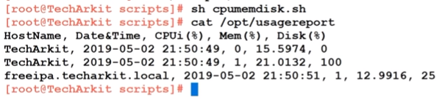
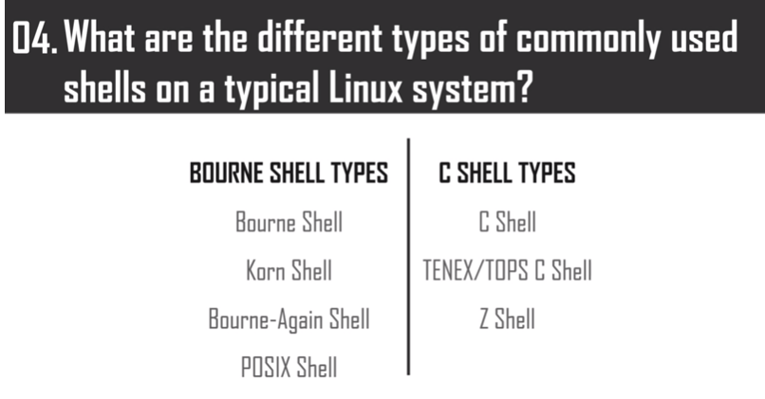

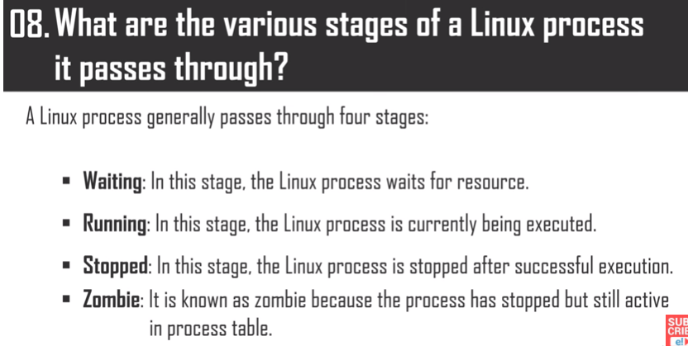
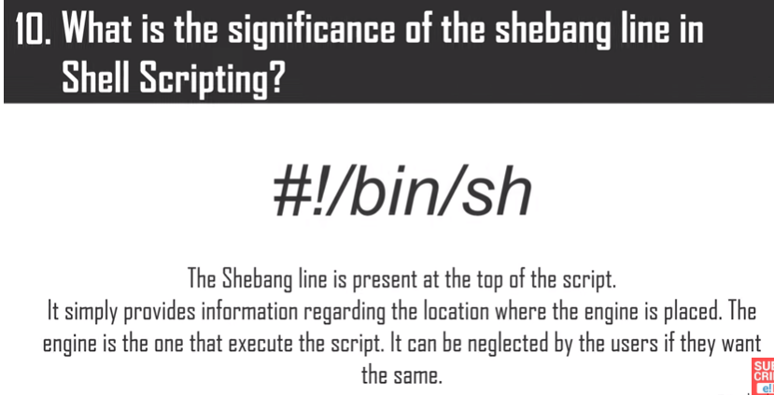
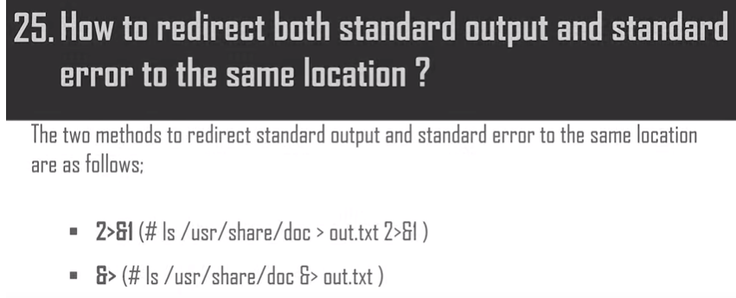
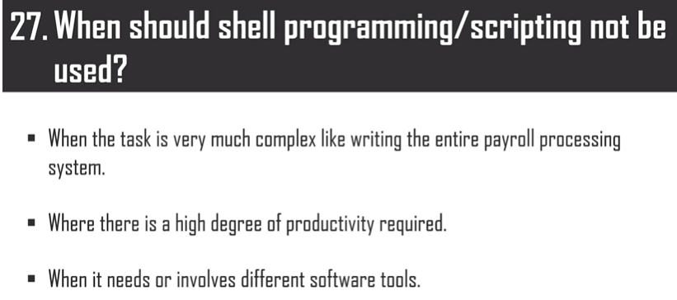
- The lifespan of variable inside the shell scripting is valid until the end of execution.

This is a interpreter by the kernel and required while we execute the script the kernel will get to know the shell specification. This will pass the other commands as interpretive directive.
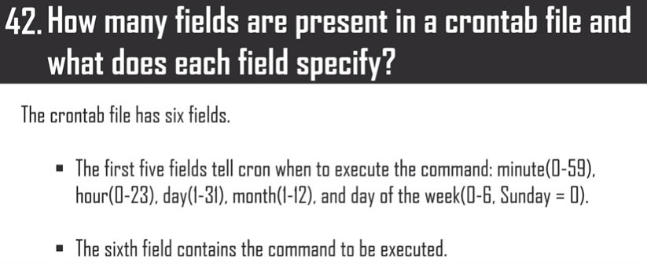
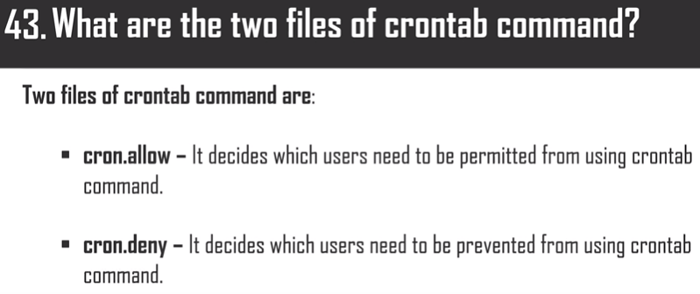
xargs
Unix-like operating system command
Descriptionxargs is a command on Unix and most Unix-like operating systems used to build and execute commands from standard input. It converts input from standard input into arguments to a command. Some commands such as grep and awk can take input either as command-line arguments or from the standard input. Wikipedia
Stands for: Extended arguments
Function: Build and execute command lines from standard input
Syntax: xargs [-0prtx] [-E eof-str] [-e[eof-str]] [--eof[=eof-str]] [--null] [-d delimiter] [--delimiter delimiter] [-I replace-str] [-i[replace-str]] [--replace[=replace-str]] [-l[max-lines]] [-L max-lines] [--max-lines[=max-lines]] [-n max-args] [--max-args=max-args] [-s max-chars] [--max-chars=max-chars] [-P max-procs] [--max-procs=max-procs] [--interactive] [--verbose] [--exit] [--no-run-if-empty] [--arg-file=file] [--show-limits] [--version] [--help] [command [initial-arguments]]
Example: xargs sh -c 'emacs "$@" < /dev/tty' emacs
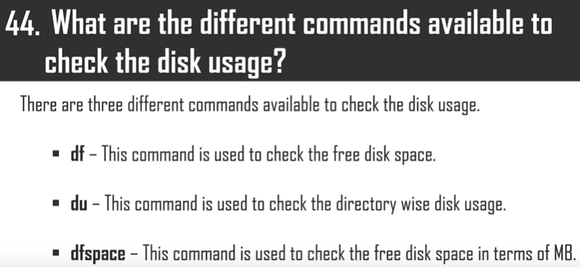
- There are 4 different communication commands available in shell
- mail
- news
- wall
- motd
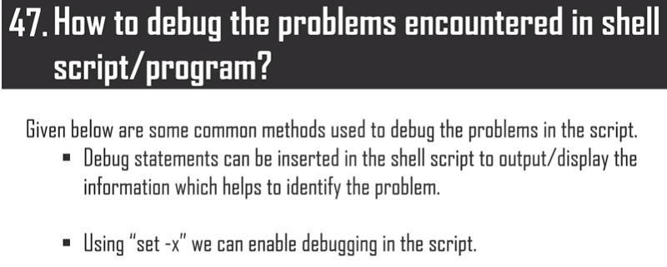


Answer:

Answer:
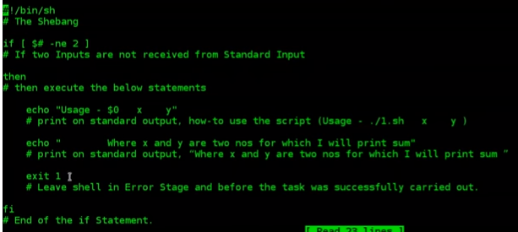

Answer:
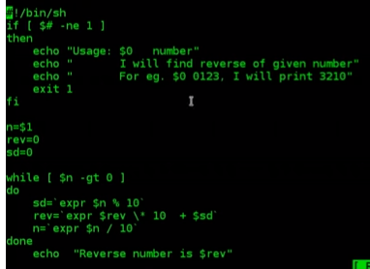
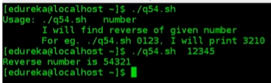

Answer:
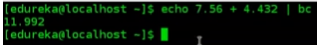

Answer:
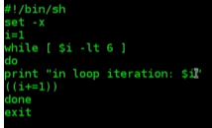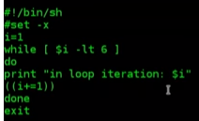
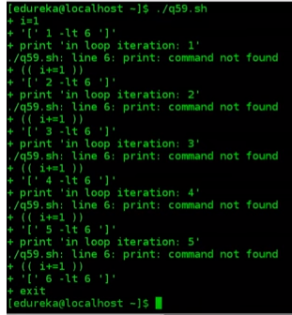
File Descriptors or FD:
0= stdin
1=stdout
2=stderr
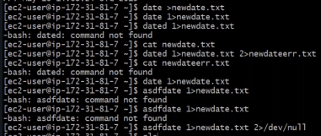
Sometimes if you are redirecting a error output to a file then no need to write the complete file name, you can apply the command as
#lsasof > out.txt 2>&1 = This means we are redirecting the error output to the first file only which we have mentioned as out.txt.
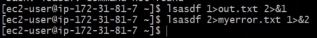
However, in real time we use log file in each and every scripts but its little difficult to use everytime same logfile name for each output of logs , hence we can use once only the logfile and everytime the output will go to same file.
For that we need to type in the first line only #exec 1>file_name
Ex:
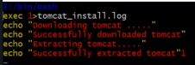
If you want to redirect the error outputs to one file and successful outputs to another, then we can follow below scripts:
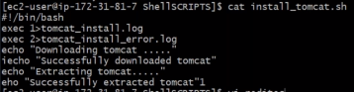
In case we need to read any file, then directly we can apply the script as exec 0<file_name 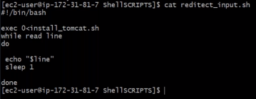
Array:
If the variable is an array, then to display this we can use as echo “${x[@]}”
Indexes : To get index of an arry, then we can use like below
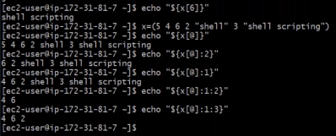
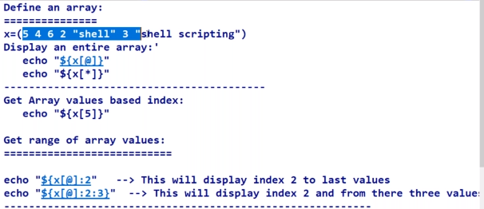
To get length of an normal string : x=”Hi” echo “${#x}”
Length of an array : echo “${x[@]}” and in the same to way to get length of a particular index echo “$x{4}”=This is for length of 4th index.
To add a new value to an existing array:
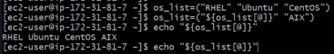
To remove one particular index from an array, then we can use as #unset os_list[5]= This will remove the index 5 from the array.
We also can array in for loop:
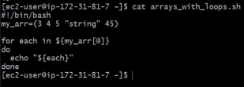
Creating an array using commands:
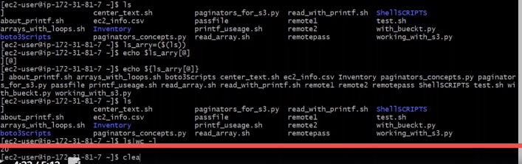
Awk commands:
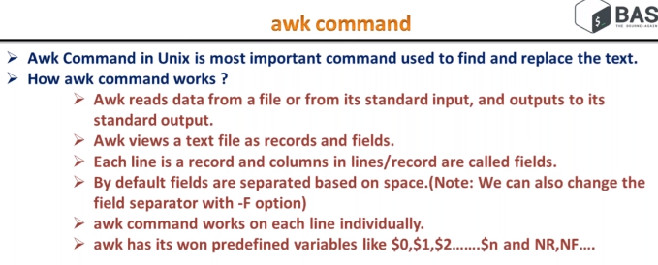
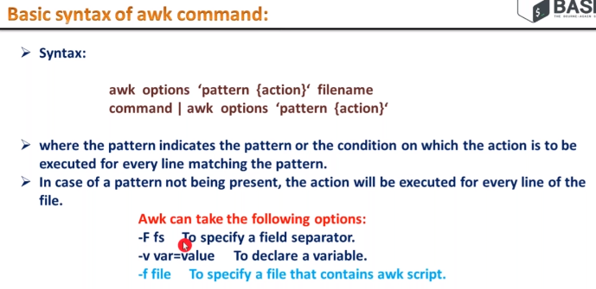
-F can be used for filed separator as by default awk command will separate as per spaces but if you want to separate a line with any other way like : or # or $ then we need to apply the command like
#cat /etc/passwd | awk –F : ‘{print $1}’
NR and NF usage and syntax: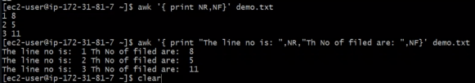
#awk ‘{ print $NF }’ <file_name>= This will give the output as last words of each sentences of that particular file.
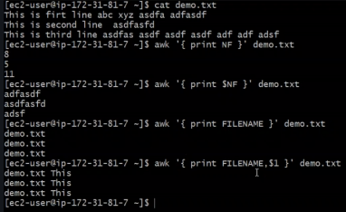
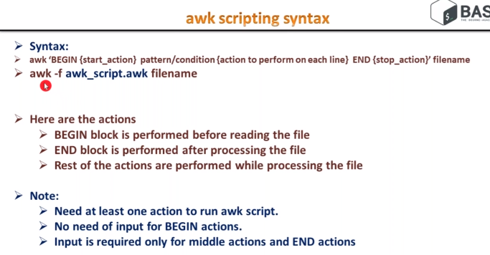
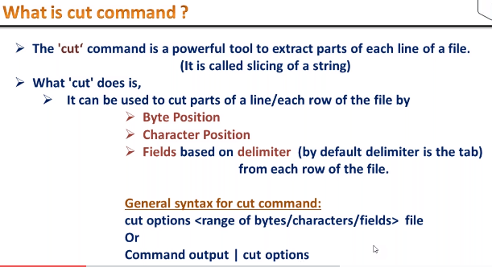
cut -b 3- /etc/passwd= This will give the output of 3rd character to end
-b for bytes and –c option is for characters.
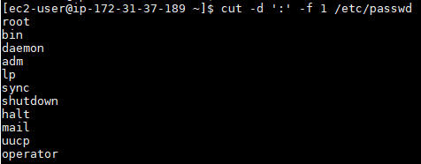
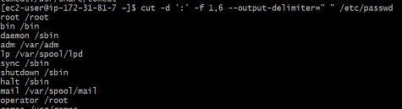
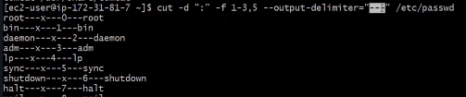
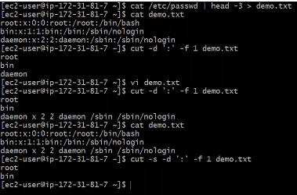
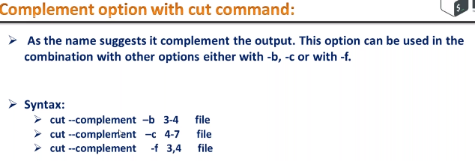
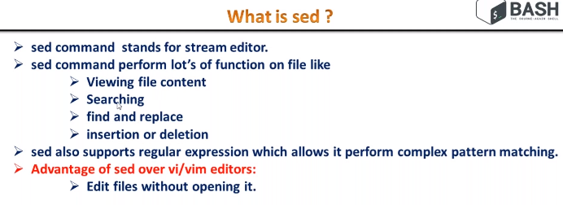
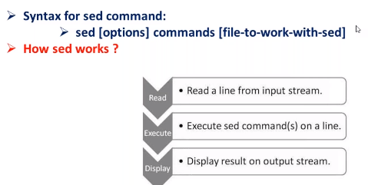
To view details of any file through sed command:
#sed ‘ ’ <filename>
#sed ‘p’ <filename>=This will give the output as duplicate sentences for each line as sed by default has print option of any sentence and again if you apply the option –p then it will reflect duplicate sentences.
#sed –n ‘p’ <filename>= To avoid duplicate sentences we can apply this commands and in this we can print line numbers as per requirement as #sed –n ‘2p’ <filename>=This will give the output of 2nd line.
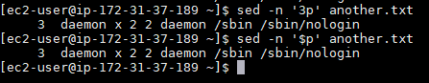
Note : $p option is for the last line
If we want to print from 3rd line to 10th line then syntax will be
#sed –n ‘3,10p’ <filename>
If we want to print from 3rd to next 7 lines
#sed –n ‘3,+7p’ <filename>
#sed –n ‘1-3p’ <filename>=This will provide the output every 3rd line like 1st line, then 4th line, then 7th line so on..
#sed ‘4d’ <filename>=This will delete the 4th line of that particular file
This all above sed commands are for temporary use that means this doesn’t impact anything to original file. so to make it permanet then we need to use as –i as option while deleting and to take back up of original file throught sed command=> #sed –i.back ‘3d’ <filename>
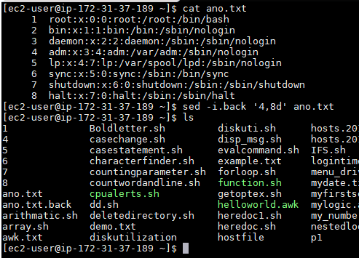
To delete or print any line having particular word then the syntax will be
#sed –n ‘/echo/p’ <filename>=This will print the lines which are having word echo in that file and to delete the lines having the word echo#sed –n ‘/echo/d’ <filename>
To delete the lines which are not having the word echo then the syntax will be
#sed –n ‘/echo/!d’ <filename>
Further if you are using any variable to delete then we need to assign the variable first like
#sed_w=”echo”
#sed –n “/$sed_w/p” <filename>
To replace the word with any other word then syntax will be
#sed –n ‘s/<current word>/<replacement word>/’ <filename>=This will replace only first word replacement of the lines but to replace in all the words
#sed –n ‘s/<current words>/<replacement word>/g’ <filename>=This will replace all the words in that files.
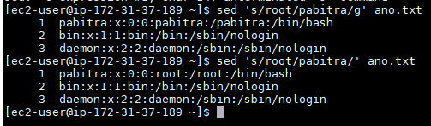
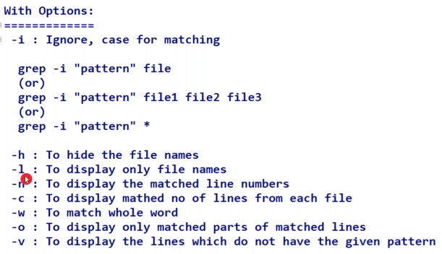
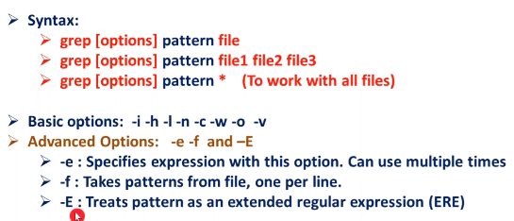
Return code functions:
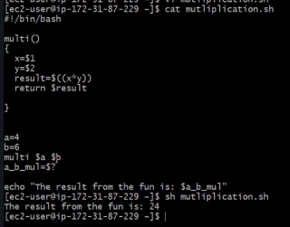
This return $result will capture by this last syntax a_b_mul=$?
Scope is two types 1. Local and 2. global scope
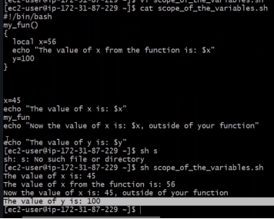
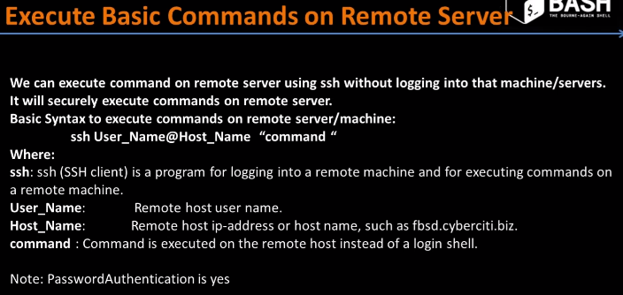
We can login to remote server through ssh command but every time it will ask for =, so as a super user, we can login to remote server with password less authentication in two ways.
- ssh keygen
- sshpass
Multiple commands running on remote servers:
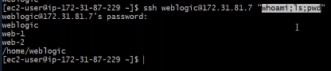
To create password less authentication, we need to follow just few simple steps those are
- #ssh-keygen
Then it will create one directory which is ./ssh and here we can find both public and private keys and we need to copy this to remote server by using command
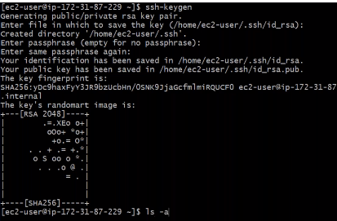
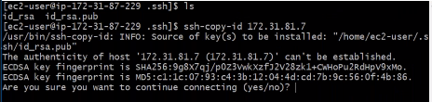
Then we need to enter the command to copy as shown in the above screen shot
#ssh-copy-id <remote server IP>
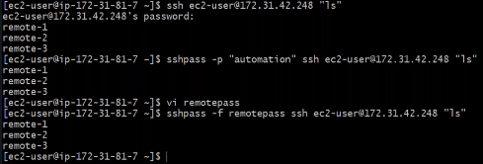
Here in the above screen shot, we can provide password directly in the command prompt, but for secure purpose we can enter the password in a file like remotepass(just an example) and access to the remote server.
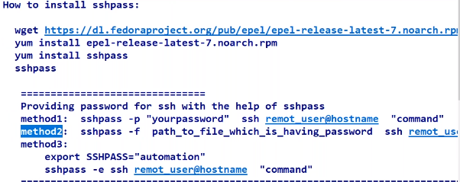
While we are remotely connecting to other remote server from local server then it will ask “Are you sure you want to continue connecting(Yes/No)?” and here we need to enter yes, then it will ask for password and to avoid this, we can follow the below screen shot procedure:
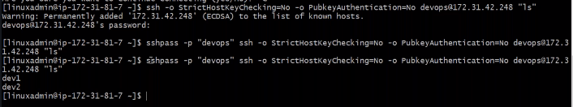
Syntax to use ssh as variable with and without password:
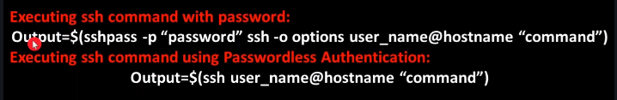
Practice 1: Design simple digital clock with shell scripting with color. 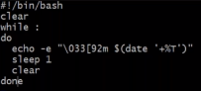
This will provide the output of clock in green color.
Practice 2:
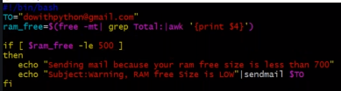
Here free –mt for MB check and for GB we can use free –gt.
However, to run this script each time, we can schedule the cron job and also we can use infinity while loop. but in real time we can use this as per the process requirement schedule cron job in every 1 hour or 2 hours.
Practice 3:
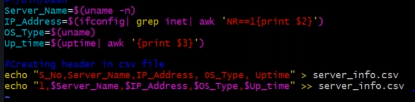
The syntaxes may vary according to the available details to get server name, IP address, OS type and uptime.
My own practice:
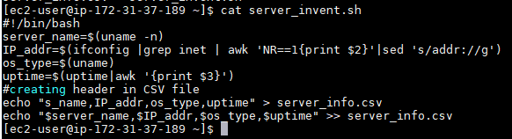
Practice -4:
Automate multiple servers inventory using shell scripts.
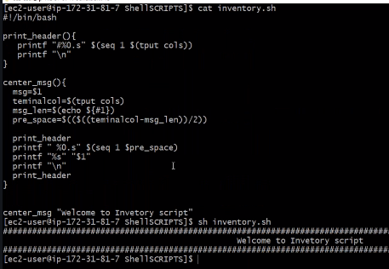
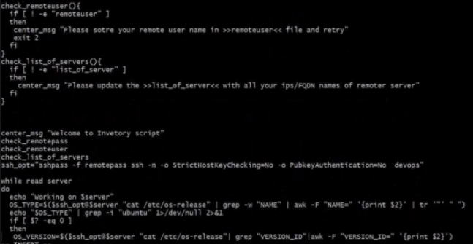
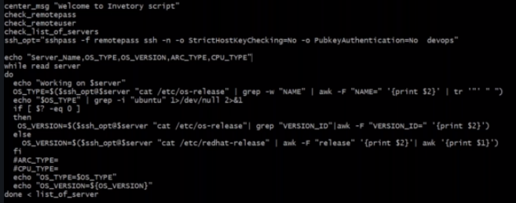
Practice 5:
and email alerts:
My practice screen shot:
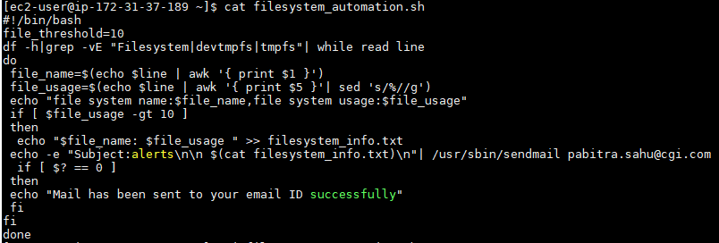
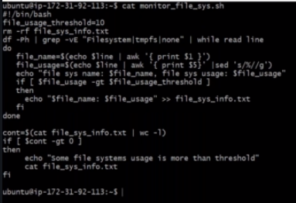

Command | Example/Usage of Command | Description
ls | 1. $ ls  2. $ ls –lrt or $ ls -ltr | 1. It lists files in the current directory.  2. It lists files in the long format.
cd | 1. $ cd  2. $ cd test  3. $ cd .. (after cd space needs to be given before entering two dots.) | 1. It changes directory to your home directory.  2. It changes directory to test.  3. It moves back to one directory or to the parent directory of your current directory.
mkdir | $ mkdir test | It creates a directory called test.
rmdir | $ rmdir test1  CAUTION: Be careful while using this command. | It removes directory test1.
cp | 1. $ cp file1 test  2. $ cp file1 file1.bak | 1. It copies file1 to test directory.  2. It takes backup of file1.
rm | $ rm file1  CAUTION: Be careful while using this command. | It removes or deletes a file1.
mv | $ mv file1 file2 | It moves or renames file1 to file2.
more | $ more | It checks or display one page at a time.
touch | $ touch test | It creates an empty file called test.
cat | 1. $ cat File1  2. $ cat test1 > test2 | 1. It displays contents of File1.  2. It creates a new file test2 with the contents of test1.
compress | $ compress file1 | It reduces the size of file1 and creates a compressed file called file1.z and deletes file1.
date | $ date  e.g. Output:  Tuesday, September 12, 2017 06:58:06 AM MDT | It displays current date and time.
diff | $ diff file1 file2 | It displays line by line difference between file1 and file2.
find | $ find . –name ‘*.t’ -print | It searches in the current directory and in all its subdirectories for files ending with .t, and writes their  names in the output.
finger | $ finger | It displays information about user.
who | $ who | It lists the users those who are logged in on the machine.
grep | 1.$ grep Hello file1  2.$ grep –c Hello file1 | 1. It searches for the lines containing Hello in file1.  2. It gives count or number of lines that contains Hello in file1.
kill | kill  $ kill 1498 | It kills the process which is having PID as 1498.
lpr | 1.$ lpr –Pprinter1 test  2.$ lp file1 | 1. It sends file test to print it on printer1.  2. It prints file1.
man | $ man ls | It displays online manual or help about ls command.
passwd | $ passwd | It is used to change the password.
pwd | $ pwd  e.g. Output: /u/user1/Shell_Scripts_2017 | It displays present working directory.
ps | $ ps  e.g. Output:  PID TTY TIME COMMAND  1498 3b 0:10 sh  1500 3b 0:05 sh | It displays the list of processes which are currently running on the machine.
talk | $ talk user1 | It is used to talk to the user1 who is currently logged into the same machine.
wc | $ wc file1  e.g. Output:  4 6 42 file1 | It counts the number of lines, words and characters in file1.
chmod | $ chmod 744 file1 | It changes the permissions of file1 & assigns this permission rwxr--r--
gzip | $ gzip file1 | It compresses the file1. After compression file1 should look like this, file1.gz
gunzip | $ gunzip file1.gz | It uncompresses the file1.gz. After uncompression file1.gz should look like this, file1
history | $ history | It lists all the commands which are recently used.
logname | $ logname  e.g. Output:  user1 | It prints log name of the user.
uname | $ uname  e.g. Output:  SunOS | It gives information about unix system which you are using.
tty | $ tty  e.g. Output:  /dev/pts/1 | It displays the device name of your terminal.
sort | $ sort file1 | This will sort the contents of file1 and displays sorted output on the screen.
head | $ head -15 file1 | It displays first 15 lines of the file.
tail | $ tail -15 file1 | It displays last 15 lines of the file.

Hard Link: Hard links are linked to the inode of the file and have to be on the same file system as of the file. Deleting the original file does not affect the hard link.
Soft Link: Soft links are linked to the file name and can reside on a different file system as well. Deleting the original file makes the soft link inactive.
- What is the significance of the Shebang line in Shell Scripting?
The Shebang line is present at the top of the script,e.g. #!/bin/sh. It simply provides information regarding the location where the engine is placed. The engine is the one that executes the script.
- How to get script name inside a script?
!/bin/sh
echo "Script Name:$0"
- How to check if the previous command was run successfully?
#!/bin/sh
var=$?
if var=0
then
echo "Script was Run successfully"

else
echo "Script was unsuccessful"
fi
- How to get the 3rd element/column from each line from a file?
#!/bin/sh
awk '{print $3}' $1

Write down the Syntax for all the loops in Shell Scripting.
For Loop:
for var in word1 word2 ... wordN
do
Statement(s) to be executed for every word.
done
While Loop:
while command
do
Statement(s) to be executed if command is true
done

until command
do
Statement(s) to be executed until command is true
done

- Differentiate between ‘ and ” quotes.
Single Quotes: Used in case evaluation of variables to values is undesired.
Double Quotes: Used in case evaluation of variables to values is required.
- How to debug the problems encountered in the shell script/program?
Given below are some common methods used to debug the problems in the script.
Debug statements can be inserted in the shell script to output/display the information which helps to identify the problem.
Using set -x we can enable debugging in the script.
- Shell Script to Check Leap Year:
A year, occurring once every four years, which has 366 days including 29 February as an intercalary day.
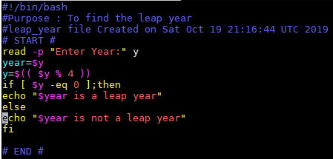
Output:
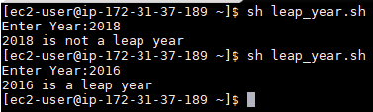
- Shell Script to Check Number is Positive or not:
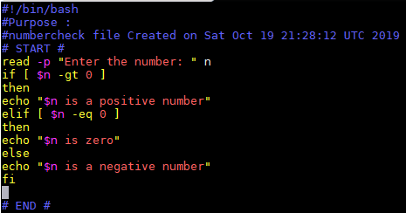
Output:
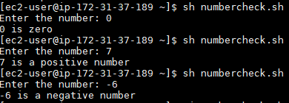
- Shell Script to find Number is Even or Odd:
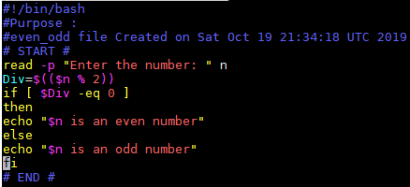
Output:
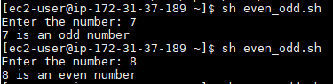
- Shell Script to find Side of a Square:
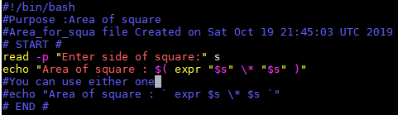
Output:
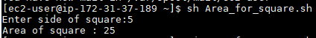
- Shell Script to Reverse a Number:
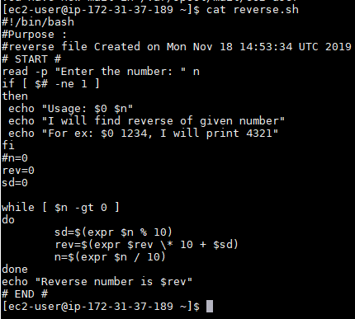
Output:
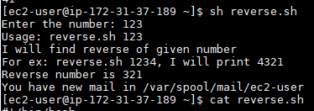
*We can set umask value permanently in /etc/bashrc file

